Vizcatán:

The Difficult but Glorious Road of the Revolution



Prairie Fire Publishing

Proletarians of all countries, unite!

This work is licensed under a Creative Commons Attribution
4.0 International License (CC BY 4.0), allowing anyone to share, adapt, and build upon this work for any purpose, even commercially, as long as appropriate credit is given to the original creator.

©︎ Prairie Fire Publishing, 2025 https://prairiefirepublishing.com/ 1st Edition

Table of Contents

Preface ⁠xii
Presentation ⁠xiii
Conversations with Comrade Laura in the Bases of the Vizcatán Mountains ⁠21
Manifesto of the Prisoners of War of the Shining Trenches of Combat 105

Communism is the ine⁠xorable goal of history, humanity marches toward it and this unfading goal will be reached no matter the vicissitudes we face today.
— Chairman Gonzalo

Communism is the future reality towards which we ine⁠xorably march. We have to go through hard and difficult stages, but us communists have the most powerful ideology: Mar⁠xism-Leninism-Maoism, principally Maoism.
— Chairman Gonzalo

Preface

We close ranks in the fight that Comrade Laura and the entire left has been carrying out with People’s War, wielding the BUP (Basis of Party Unity), and Gonzalo Thought — which in essence is: People’s War until Communism — which they have been imposing in the Main Regional Committee (MRC) of the Party as part of the General Reorganization of the Party. Step by step, solid foundations are being laid, preparing for a leap in Party work and the development of the People’s War.

Communist Party of Peru
November 2017

Below we present two documents from the Communist Party of Peru that belong to the study, Vizcatán: The Difficult but Glorious Path of the Revolution, and they are:
- Presentation by Comrade Laura (2017) preceded by the cover of the book and followed by some photos of Comrade Laura.
- Manifesto of the prisoners of war from the shining trenches of combat to understand the current process of the Party and the People’s War.
Peru People’s Movement (MPP)
December 2017

Presentation
Comrade Laura Vizcatán, 2017

Humanity’s long march in transforming matter has generated great and profound changes in the investigation of nature, society, and thought. As the ideology of the international proletariat, as the last class in history, the only true and transformative one: Marxism-Leninism-Maoism, Gonzalo Thought; it has given the earth the best and most highly organized and powerful nations, such as the USSR of Lenin and Stalin, and the China of Chairman Mao Zedong. The fact that it has been usurped by revisionists does not detract from the universal validity of the ideology, which remains strong, undefeated, and latent, being the only truly revolutionary and transformative ideology.
Amid heroic struggles, the proletariat of Peru, with José Carlos Mariátegui, has formed the Communist Party of Peru, which, as our founder said, is “Marxist-Leninist, convinced and confessed.” In the earth-shaking class struggle and the storm of revolution, the international proletariat built Socialism in what was the USSR, with Lenin and Stalin.
Through the People’s War, the proletariat of China established the People’s Republic of Workers and Peasants, uninterruptedly building the socialist dictatorship of the proletariat and the Great Proletarian Cultural Revolution, to maintain the course and prevent capitalist restoration. Our undefeated ideology was established as Marxism-Leninism,
Mao Zedong Thought, and later, as a result of the initiation and development of the People’s War in Peru, it has been better understood in its application and has made a qualitative leap in its development, becoming Marxism-Leninism-Maoism, with Maoism being the third, new, and higher stage of the ideology of the proletariat and therefore decisive for the World Proletarian Revolution.
Consequently, the ideology of the international proletariat is Marxism-Leninism-Maoism, principally Maoism, as the third, new, and higher stage.
The People’s War, which was initiated in May 1980, is a historic milestone of struggle. It has ignited bright hopes for the construction of the People’s Republic of Peru and has called on the communists, combatants, and masses of Peru to join in this great epic that will crown their victory with the seizure of power in the entire country and the triumph of the Revolution, whatever the circumstances that must be endured and paid for. Together with our comrades, in heroic struggle, we offer and will continue to offer our blood and our lives to maintain the road of the People’s War that leads to the realm of eternal harmony, Communism, the ultimate goal of all humanity.
The class struggle, the heroic struggles of the Peruvian proletariat, in a hard fight have generated Chairman Gonzalo and Gonzalo Thought, which is the creative application of Maoism to the Peruvian Revolution; in years of intense, tenacious and incessant struggle to uphold, defend, and apply Marxism-Leninism-Maoism, retaking the road of Mariátegui, reconstituting the Party and initiating, maintaining, and developing the People’s War; our great leadership with recognized authority and influence.
In Peru, the armed revolution, the working-class as the leading class, and the Communist Party as the party of the working-class, that is to say, our own reality of revolution, class, and Party, have generated Gonzalo Thought, out of historical necessity and chance. Marxism-Leninism-Maoism cannot be conceived without Gonzalo Thought, the essence of Gonzalo Thought being the creative application of Marxism-Leninism- Maoism to our reality. The key is understanding the process of the development of the ideology of the proletariat in its three moments or stages: that of Marx, that of Lenin, and that of Chairman Mao Zedong. Therefore, we reiterate that the essence is the application of Marxism-Leninism-Maoism as a universal truth to the concrete conditions of the Peruvian Revolution.
Chairman Gonzalo, “man of thought and action,” has reaffirmed, from the dungeons of this outdated order, his communist spirit, his status as a teacher of communists, and his tireless struggle, declaring: “I am a Marxist-Leninist-Maoist, and I will remain so until death.” The theory and ideology of the proletariat have forged us: “The hero arrives at his goal bloodied and torn: only at this price does he achieve the fullness of his heroism.” And our final sentence: “Today, as yesterday, a political order cannot be changed without men determined to resist prison or exile (…) for a revolutionary, prison is simply a work accident.”
Chairman Gonzalo, Leader of the Party, the First Congress, the Marxist-Leninist-Maoist, Gonzalo Thought Congress, the Party, the class, and the Revolution warn us: Combat imperialism, revisionism, and reaction relentlessly and uncompromisingly. Combat revisionism as the main danger in the Party and in the national and international class struggle.
Imperialism, whether American, Russian, or whatever, is a parasite that sucks the blood of the people. We do not need this parasite; to end this plague, there is only one road: the People’s War. In the not-too-distant future, when this parasite called imperialism has been swept from every corner of the earth, when the exploitation of man by man has died out, parties, classes, states, and wars will have become extinct. In other words, once all instruments of oppression have disappeared, all of humanity will enter the realm of great harmony, communist society, the unalterable final goal of humanity, the realm of humanity. The People’s War in Peru is a step forward on this inexorable road that all of humanity is traveling and will continue to travel.
Numerous combatants and masses have offered their lives. Numerous families have seen the lives of young people cut short, whose smiles, efforts and sacrifices encourage our people. The blood shed by our heroes will not be in vain, as the armed revolution is already bearing fruit. History will record in its pages the price demanded by the Revolution, and that the life of a communist belongs entirely to the Party. The hour of triumph is not far off. Let us transform our tears and pain into an ardent cry of war, for the oppressors cannot boast of their perpetuation on the face of the earth. Their hour has come, and we call for this heroic feat, for only with the gun can the world be transformed.
The Marxist-Leninist-Maoist, Gonzalo Thought Communist Party of Peru, the Party of the working-class, is the standard- bearer of our Revolution, the heroic fighter that will lead us to the inevitable final victory over the oppressors, the conquest of power throughout Peru, and our unalterable goal: Communism. “Proletarians of all countries, unite,” armed with your undefeated and all-powerful ideology, Marxism-Leninism- Maoism, Gonzalo Thought, constituting or reconstituting Communist Parties, we, your communist children, will not fail
you. Tested in a thousand battles, offering our blood and our lives, we will fulfill our journey so that the unfading light of Communism may shine upon the earth. The road of People’s War is open, and the peoples of the world, workers, peasants, the petty-bourgeoisie, and even the national bourgeoisie must walk it. There is only one road, People’s War; only one objective, the People’s Republic; only one unalterable goal, Communism.
The writer Miguel de Unamuno says in one of his poems: “There are eyes that see, there are eyes that dream, there are eyes that call, there are eyes that wait.” But the eyes of the people see, dream, call, and wait for the undefeated and all- powerful ideology of the proletariat, and they set to work for the New Democratic People’s Republic, passing uninterruptedly to Socialism and the final goal of humanity, Communism.
We reiterate, once again, our firm commitment to give our lives alongside the masses who create everything new and to fight to the last drop of blood in defense of the Party and the Revolution. We proclaim here our decision to fight as children of the Party, children of the Revolution, and, with great honor, children of Chairman Gonzalo.
What we present below is a very brief study of the process and development of Peruvian society. Although we provide only summary information, our point of view can contribute to a more detailed and in-depth study, as demanded by communist conviction, the life of the Party, and the Revolution.

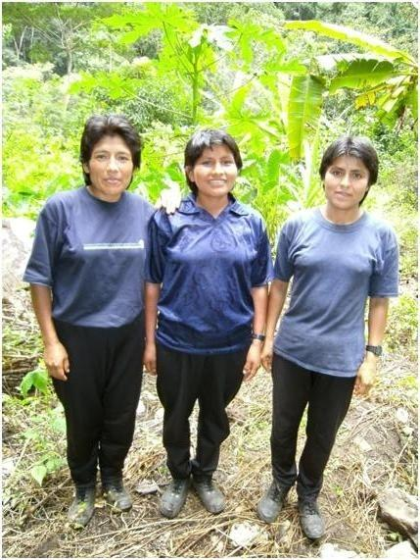

Comrades Laura, Maruja, and Mariela.

Roblepampa 2012.

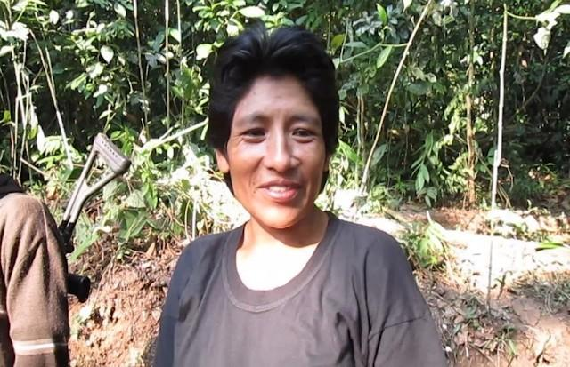
Comrade Laura in Pampa Aurora.

August 2014.

Conversations with Comrade Laura in the Bases of the Vizcatán Mountains

Introduction

Peru People’s Movement (Reorganization Committee) March 2017

Today we publish the Conversations with Comrade Laura in the Bases of the Vizcatán Mountains, in the VRAEM,1 carried out around 2012. The essence of the interview is that in it, as it must be, with People’s War, the defense of Chairman Gonzalo, the Great leadership of the Party and the Revolution, Gonzalo Thought, the First Congress, and the Basis of Party Unity, and of the entire road traveled so far is assumed, and a firm position is taken against the revisionist and capitulationist right- opportunist line led by the rat Miriam and especially against the revisionist and capitulationist right-opportunist line, which is disguised as the left, of the rat José and his litter who usurped the Main Regional Committee. We consider it to be a masterful Marxist-Leninist-Maoist, Gonzalo Thought document.
With the Party documentation in hand, Comrade Laura, from the Vizcatán mountains, with deep class sentiment and hatred, with firm conviction and communist position, and with the ideology of Marxism-Leninism-Maoism, Gonzalo Thought assumes the defense of our Great leadership, Chairman Gonzalo, and his all-powerful thought and demarcates, crushes, and sweeps away all the hoaxes of the CIA-Peruvian reaction and its servants of the new revisionism against Chairman Gonzalo, the Communist Party of Peru, and the People’s War.

1Valley of the Apurímac, Ene, and Mantaro Rivers. — PFP
Conversations with Comrade Laura...

With this interview we document how the left struggles to impose the red line in the VRAEM with People’s War. Thus, the communists, combatants, and masses, practicing the philosophy of struggle that the world can only be transformed with guns, are struggling to carry out the reorganization of the Main Regional Committee of the Communist Party of Peru as part of the General Reorganization of the entire Party in the midst of the People’s War while fighting to the death against the new revisionism.
It is a document with which the two-line struggle was imposed in the Party in 2013, therefore it expresses how the two-line struggle was being handled at that time, which served as the basis for taking the leap in the Party task of the General Reorganization of the Party around May 2014. It thus shows part of that process. So there will be many questions that readers can ask themselves about various aspects, some surely very important about this struggle, and which are revealed in the interview. Many have already been resolved in the elapsed time and others are surely still being resolved with the development of the General Reorganization of the Party in the midst of the People’s War. This interview shows us that we are getting closer to its brilliant culmination.
Furthermore, the problem of sweeping away all that opposes the Great Leadership and Gonzalo Thought through two- line struggle is a complex problem and one that demands to be done thoroughly. Because, as it is established, only by making ourselves firmly adherent to the leadership of Chairman Gonzalo and his all-powerful thought and developing a firm and sharp two-line struggle to keep the Party red can we advance in the People’s War and firmly maintain its course.
Vizcatán: The Difficult but Glorious Road of the Revolution

There are some photographs that have been sent to us that we have not published in order to preserve the revolutionary secrecy regarding the photos in which Laura and the interviewer appear, and others for various other reasons.2 In any case, this is our first edition of these important conversations; it is certain that more will follow.
We are sure that this publication will raise the revolutionary optimism and joy of all Maoists and other revolutionaries in the world, and especially in Latin America, to the highest level.

2Since the original publication of this interview in 2017, most of the previously redacted photos have been published online by New Democracy Association-Germany (vnd- peru.blogspot.com). We have inlcuded them in this edition. — PFP

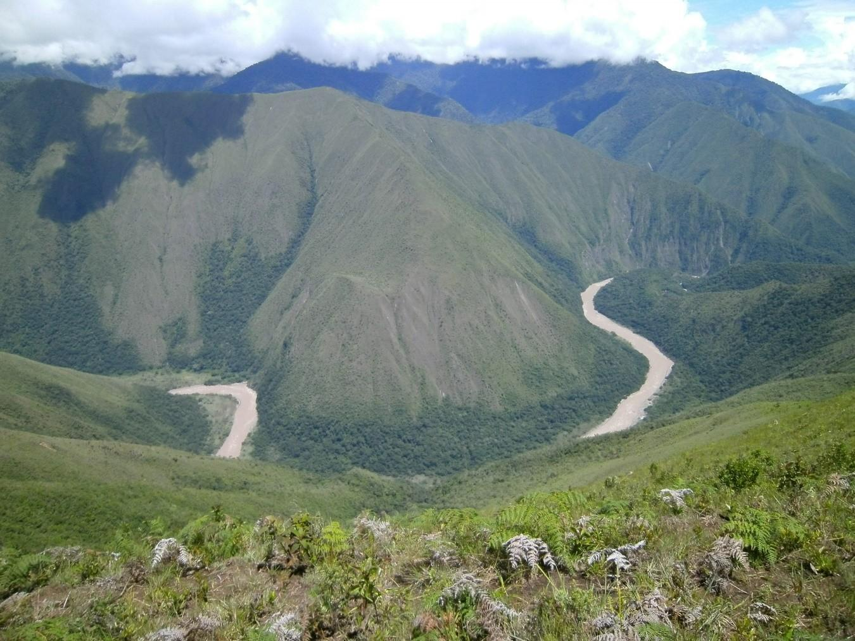

The Third Moment of Contemporary Peruvian Society: Conversations with Comrade Laura in the Bases of the Vizcatán Mountains

Let us give way to Comrade Laura, so that this process of Peruvian society may reach posterity with the greatest clarity. This conversation took place in the sector called Roblepampa on the banks of the Imaybamba River, border between the departments of Huancavelica and Ayacucho.
The Imaybamba River descends from the heights of Sanabamba, part of its flow comes from the highlands of Tayacaja, and in its course it flows into the Mantaro River, almost at the sector called Purisima, a little further downstream of Mantaro. All this place is part of what is called the glorious and warrior Vizcatán.

Comrade Laura affirms:
I will lead by expressing my subjection to Chairman Gonzalo, Leader of the Party and the Revolution, to the Communist Party of Peru, to the undefeated ideology of the proletariat: Marxism- Leninism-Maoism, Gonzalo Thought, to . . . the People’s War in Peru.
The year 1980 has a special denomination, it is ILA-80.3 As years pass, its importance will be marked in an unfading way, as it already is, because from there, the future birth of the People’s Republic of Peru has been engraved on the back of the Andes. We are entering a crucial moment, a moment of the general crisis of bureaucrat-capitalism; Peruvian society, as a system, has expired in these almost two hundred years of republican life. This period, moreover, is marked by the armed struggle between revolution and counter-revolution; this fiery struggle of the Peruvian people has served for the whole world to

3Initiation of Armed Struggle — 1980. — PFP
Conversations with Comrade Laura...

understand that the ideology of the proletariat, in hard struggle, has reached its third, new, and higher stage: Marxism-Leninism- Maoism, with Maoism becoming the fundamental and decisive thing in the world to carry out proletarian revolutions. In Peru it has special importance as Marxism-Leninism-Maoism, Gonzalo Thought. An epoch has been opened whose first part must culminate with the establishment of a New State of Workers and Peasants, a New Democratic People’s Republic, whatever the circumstances that have to be passed through.
After more than eleven years of military government and General Francisco Morales Bermudez being the de facto President, having installed a Constituent Assembly that sanctioned the Charter of 1979, elections were called for May 1980, the date on which a President was to be elected and should begin its operation, with its powers in the liberal-democratic style, which the ruling classes called Democracy, also called by the direct actors of that time, transfer of power to the civilian population.
The year 1980 saw the transfer of power from the hands of the Armed Forces, with a new Magna Carta that constituted the third restructuring of the Peruvian state in the 20th century. Since then, successive governments have had a central problem: the People’s War led by the Communist Party of Peru.

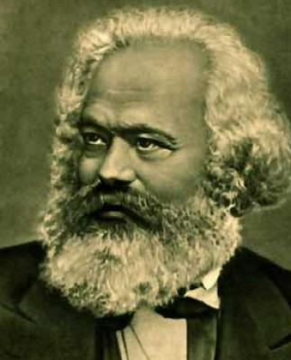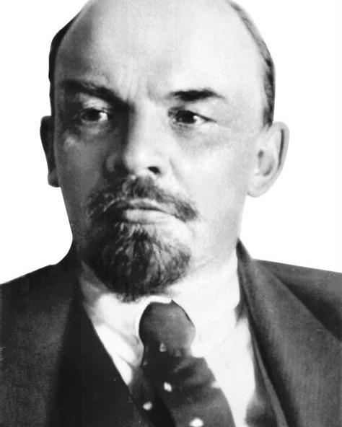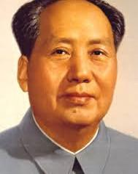
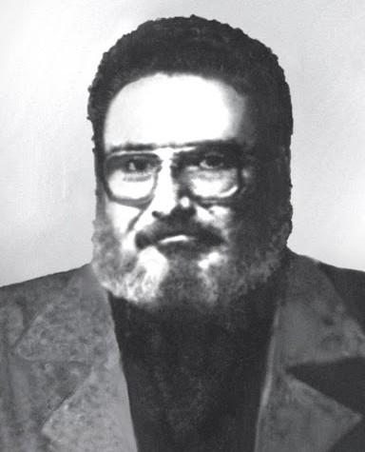

Marxism-Leninism-Maoism, Gonzalo Thought. The highest ideology of the working-class, raised to the top by the Communist Party of Peru.
Conversations with Comrade Laura...

This People’s War is confronted by the reactionary state of Peru, using counter-revolutionary policies of masses against masses and in the midst of a barbaric genocide, they attempt to defeat what they call armed subversion. We fought ardently, to ignite the People’s War more, to build the New Power and at the cost of the blood shed by the communists and the children of the people, we managed to open base areas and enter into guerrilla warfare, which ignites shining hopes to put an end to the enslavement of man by man.

Photo of Comrade Laura not included.

The following image was taken by the author, in the sector called Roblepampa, advancing somewhat more downstream; to the borders of the Imaybamba river, tributary of the Mantaro river, current county of Tayacaja. This river marks the limit between the departments of Huancavelica and Ayacucho. Of course, the left bank of the Mantaro already belongs to the department of Junín.

Due to lack of adequate material and . . . it was not possible to record the conversation, for which reason we note down only some questions that we consider fundamental or those that were very easy to record.

30

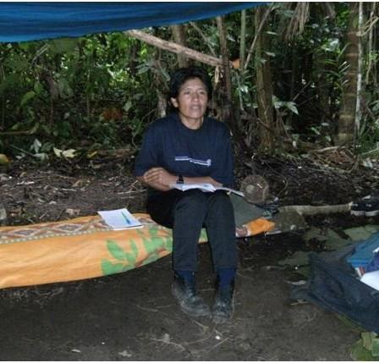

Comrade Laura. September 2012. Roblepampa.
Conversations with Comrade Laura...

In the following dialogue, Comrade Laura began by commenting on the Great Proletarian Cultural Revolution, which she considers of utmost importance. As the conversation went on, questions arose. I would say that there was no interview plan. This dialogue was carried out in the view and presence of Comrade Mariela, who also appears in the photo and nodded when Comrade Laura’s presentation was prolonged.

“Comrade Laura, Tell Us Something About Your Life in Vizcatán.
What Is the Daily Work of the Guerrillas?”

We have always judged it more important to develop our lives as part of the Party and the Revolution. We believe that life, short or long, should be useful to the most sublime of humanity: the struggle for Communism . . . and we firmly believe in the building of the People’s Republic of Peru, a Republic of New Democracy, we believe in the Revolution, in the armed struggle; we raise to the top the great slogan of Chairman Mao: Political power grows out of the barrel of a gun. This great process of the Revolution in Peru is led by the working-class, through its Party, it is the one that sets the course and it is the Party of the working-class, the Communist Party of Peru that will guide us to our final goal. We reiterate, a Marxist-Leninist-Maoist, Gonzalo Thought Party. The scientific ideology of the proletariat, being Maoism, the fundamental and decisive thing for the World Proletarian Revolution, and Gonzalo Thought for the Peruvian Revolution, for being the creative application of Maoism to our reality. We reiterate our philosophy of struggle that the world can only be transformed with guns. Many hearts, together with ours, have already undertaken this heroic deed, which will lead humanity to the final goal, which is Communism.
Vizcatán: The Difficult but Glorious Road of the Revolution

I don’t think it’s worth telling this chapter of my life, simply because our lives are made as a part of the Party and the Revolution. We only strive to fulfill our journey well.
Together with our comrades, on repeated occasions, we have given our firm commitment to give up our lives for the Party and the Revolution, for our unalterable goal, which is Communism, knowing that after our death, other hands will wield the gun with equal or greater skill. We can proclaim before the world and before Marxism-Leninism-Maoism, Gonzalo Thought, that the struggle we are waging is the final struggle for the reign of eternal harmony, a society without rich or poor, the forever luminous Communism.
The Great Proletarian Cultural Revolution, a powerful mass movement, led by Chairman Mao Zedong, in the midst of socialist construction in China. It is the revolution never seen on Earth, because for a long time, the proletariat remained in complete power. This Great Proletarian Cultural Revolution, aimed directly against the bourgeoisie, against those leaders and followers of the capitalist road, such as the “Chinese Khrushchev” Liu Shaoqi, and also served to fight against the right-wing revocatory wind of the sinister Deng Xiaoping. The proletariat, led by the great, glorious, and correct Communist Party of China, under the leadership of Chairman Mao Zedong, organized in People’s Communes seized power from the hands of the bourgeoisie that had infiltrated the Party, the same leaders as those already mentioned.
The famous “January Storm” was unleashed in Shanghai, in which, in the midst of a fierce class struggle, Comrade Jiang Qing, wife of Chairman Mao Zedong, and other leaders such as Zhang Chunqiao, Wang Hongwen, and Yao Wenyuan distinguished themselves. When the counter-revolutionary coup d’état of October 1976 took place, our Party launched its
Conversations with Comrade Laura...

resounding war cry to the world with the slogan “Long Live the Shanghai Four,” taking a firm and tenacious stand to combat the revisionism of Deng Xiaoping; the triple revisionist attack: the Albanian Revisionism of Ramiz Alia, the Soviet Revisionism of Brezhnev, and the Chinese revisionism of Deng Xiaoping. Chairman Gonzalo, in a heroic and tenacious struggle, leading the Communist Party of Peru, launched to the world the highest proletarian slogan, the highest ideology of the proletariat: “Long Live Maoism!” As the third, new, and higher stage of the ideology of the proletariat.
The Great Proletarian Cultural Revolution is the greatest milestone of the World Proletarian Revolution and is the fight to the death between revolution and counter-revolution, between restoration and counter-restoration. With this powerful mass movement unparalleled in history, the ideology of the proletariat became Marxism-Leninism-Maoism, principally Maoism, essential to lead the revolution and to reconstitute proletarian parties in the world.
I consider this moment in the history of Peru to be of transcendental importance, because at the national and international level there has been an arduous struggle to put an end to the domination of American, Russian, or any other imperialism, to put an end to the slavery of the Peruvian people, the slavery by the ruling classes: The big landlords, the big bourgeoisie, the big bankers, having the state as their instrument, with the armed forces and police forces as their backbone, exercise their domination over our people. It must be clearly established that the bourgeoisie has reached its highest and final stage of its development, the stage of imperialism, whose characteristic is monopolistic, parasitic, and agonizing, as Lenin has taught us; this system is struggling in a massive crisis, which it intends to solve by invading other peoples, to plunder their wealth and enslave them. Under the pretext of “total
Vizcatán: The Difficult but Glorious Road of the Revolution

war on terrorism,” all the imperialists, en masse, have launched themselves into aggression against the peoples. Aggression, headed by the United States.
What they want is a new division of the world, a division in which they want control of Europe. It is mainly American imperialism, as well as Russian social-imperialism and other imperialist countries, that serve as the source of wars throughout the world. As such, the American imperialists and their allies (France, England, Russia, etc.) have invaded the Arab countries: Syria and Iraq; the Middle East: Afghanistan, Iraq, Palestine, Lebanon, Libya, Syria, etc. U.S. troops are also in Peru, the Pichari Base.
The DEA, under the pretext of fighting drug trafficking, which in reality is against the People’s War, against the Peruvian people, being a necessity of the Peruvian reactionary government, to develop a low-intensity war, to demand more economic aid and prepare the military intervention of mainly
U.S. imperialism. The Islamic State is a consequence of imperialist aggression; the imperialists, with their infamous aggression, have engendered this movement and today they can be blamed for it. We, from Peru, make a solemn call for these attacked peoples to rise up in People’s War, organizing themselves in the People’s Liberation Army, led by the Marxist-Leninist-Maoist Communist Party, and brandishing the slogans “Long Live the Arab People!” and “Yankees Go Home, Yankees Out!”
In Peru, we give our firm commitment to defeat the Southern Command, whatever the price and however long it takes. Imperialist aggressors will never prevail, it is imperialism and revisionism of all kinds that will be defeated. History has proven this ad nauseam. We remind U.S. imperialism: Peru and other places where you have unleashed aggression are nothing but
Conversations with Comrade Laura...

many Vietnams to you, with the only difference being that in Peru we have taken up arms against you and will not give up until Communism shines on the face of the Earth.
Contemporary Peruvian society has expired, it is in the midst of a generalized crisis. An economic, political, and ideological crisis. The successive governments in office, claiming to solve this crisis, just deepen it, as we are clearly seeing today. The same corrupt people as always, for example, say that they are fighting against corruption. This is unheard of. Corruption is rampant in the high spheres of the reactionary state of Peru. There is no way out. The only thing left is the revolution in motion.
As far as we are concerned, we want to reiterate, as many times as necessary, so that it remains clear throughout history and so that the peoples of the world may learn from our mistakes and errors, that it is the Communist Party of Peru that has dared to initiate the People’s War and we have been carrying it forward for several years. The main foundation for sustaining this war is the ideology of the proletariat: Marxism-Leninism- Maoism, Gonzalo Thought, invincible and all-powerful. The only true way to transform society: People’s War. There is no other way.
In history, in the development of society, the different systems have given way to a more developed stage when they expire. However, once again it should be stressed: there is no historical precedent in which one class cedes power to another and happily withdraws from the stage of history. Transformations can only be realized through the storm of revolution.
In these circumstances, in September 1992, it produced the detention of Chairman Gonzalo, and our Party, tested in a thousand fights and sustained by the undefeated ideology of
Vizcatán: The Difficult but Glorious Road of the Revolution

the proletariat: Marxism-Leninism-Maoism, Gonzalo Thought, had to face this bend; in difficult moments all kinds of monsters arise, nursed and sheltered by imperialism, mainly American imperialism, such as the revisionists of the “peace accords” sheltered in MOVADEF; these miserable traitors launched to the world, with unbridled determination, the supposed “peace, pacification and dialogue,” the stupidest idea to poison the class, the masses. Us communists are built for the hardest difficulties.
The imperialists and revisionists, in holy alliance, shout to the wind about the supposed “defeat of the Party,” “the defeat of Socialism,” “the expiration of Marxism.” We warn them, no matter how much they fire cannons, no matter how much they fire devastating blows, prepare the most artful genocide against the people, they will not be able to prevail. We are ready to pass the river of blood that the revolution demands, to reach our unalterable goal, Communism.
The universal validity of Maoism is for us the highest science of revolution and a thunderous wake-up call for the imperialists, revisionists, and opportunists of all stripes. The truth of Marxism-Leninism-Maoism, Gonzalo Thought, is irresistible. The popular masses will always rise up in revolution. The world revolution will triumph unstoppably. This is demanded by Maoism and we will fulfill it.
Chairman Gonzalo has strongly affirmed:

Marxism has not taken a step in life nor achieved anything without struggle, seized with effort, and Maoism is not and will not be an exception; the struggle for Maoism, as the third stage of Marxism is and will be hard, long, complex, and difficult, it will never impose itself spontaneously. Our history is: struggle, effort, unbending tenacity, indeclinable persistence, and time for practice to test and sanction the truth, and we have no other way.
Conversations with Comrade Laura...

Everything that is new has to be imposed in an ardent struggle, fighting against the old that refuses to die, nothing has been given to us for a bargain, we have seized everything with effort, with our blood, and with luminous lives that without hesitation have been offered for the Party and the Revolution. For that we have been forged as communists, with light in our minds, steel in our chests, sword in our hands, and defiance of death.

Fight the battle and you will know how it unfolds. Us communists are bold and we are bold because we are consistent materialists, we are not afraid to be wrong, nor are we afraid to confront anyone because the truth is on our side. This is our conviction and we can’t have any other; we are men of conviction, “convicted and confessed” of the greatest transformative scientific ideology, proven in thousands of glorious battles. There was not and there is not any ideology on Earth that has had the practical proof of Marxism- Leninism-Maoism; nor ever so many millions were and will be swept away by such a powerful revolutionary storm.
— Chairman Gonzalo
Photo of Comrade Laura not included.

August 2010.

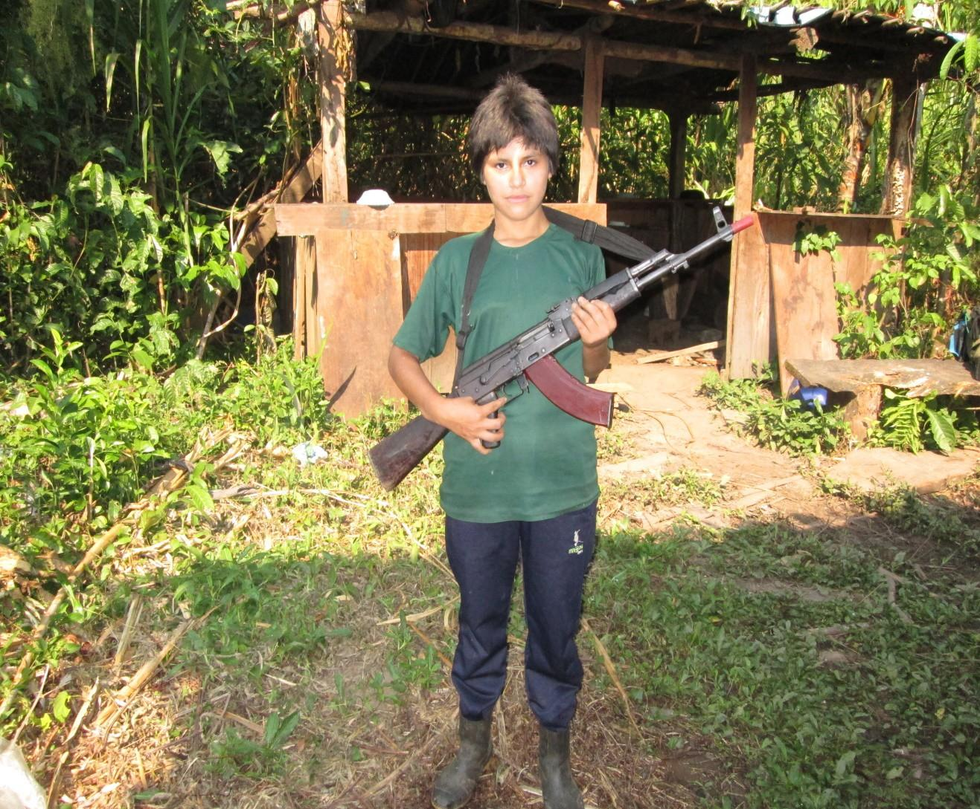

A combatant.

Our fierce decision to fight to the last drop of blood, in defense of the Party and the Revolution, under the undefeated banners of Mar⁠xism-Leninism-Maoism, Gonzalo Thought; to establish the People’s Republic of Peru: of New Democracy, without any intermediary, to build Socialism, to maintain the power of the working-class, through successive cultural revolutions and together with the peoples of the world, to reach the beautiful and luminous Communism, the final goal of humanity.

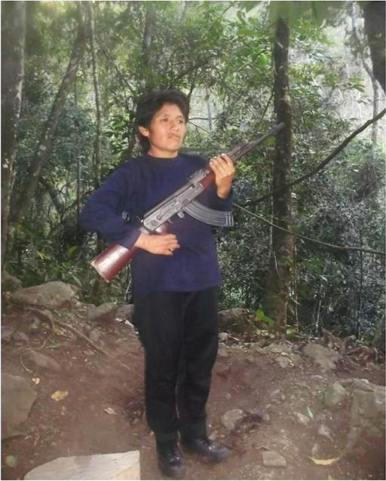

Comrade Laura on the shores of the Purísima river, tributary of the Mantaro River. August 2010.
Conversations with Comrade Laura...

“Comrade, Tell Us How You Began Your Study of the Party Principles.”

In my youthful years, back in the third year of high school, I had the opportunity to get to know Broad and Alien is the World, a work by the illustrative writer Ciro Alegría. A novel that my father admired and perhaps for this reason I was interested in reading it quite avidly . . . I believe. Rumi became my community. I became friends with its Mayor Mr. Rosendo Maqui, his children and grandchildren. Of Doroteo Quispe, Eloy Condorumi, and Jerónimo Cahua, of Clemente Yacu and Valencio; also of the ox Mosco and the bull Choloque.
I paid special attention to Fiero Vasquez, but even more to Benito Castro; to fight for the land and against oppression it is right to go beyond the limits established by the powerful; daring is the problem. If our lives are surrendered in midst of the struggle, good luck, we have shown the oppressor that we are invincible by daring to take up arms, knowing that our defeats are transitory and momentary, absolutely transitory and momentary, awaiting the final triumph; while the ferocity of the oppressor, paints it in full body, the inescapable end of its decline and its definitive defeat. This I learned with Benito Castro.

“Comrade, Tell Us More About Broad and Alien Is the World.”

Chapter VIII of this book is titled: History and Mining Lances. It deeply marked my understanding, I was definitely oriented towards the Party and the Revolution. After the death of Calixto Paucar, in this chapter you can read: “What do they think Jack is? He’s already convinced me: we’re socialists . . .”
Vizcatán: The Difficult but Glorious Road of the Revolution

Socialism. That magic word that torments the rulers of Peru so much. The word that turns their gloomy nights into a nightmare for the rulers in office. Socialism has awakened in us the enthusiasm and joy that it is worth dying for. There is nothing more glorious than to cover ourselves with the red flag and defiantly throw ourselves into the heart of the battle, fully conscious of our historic mission, to overthrow the old order and build a new one, the People’s Republic of Peru, in the image and likeness of the working-class, in accordance with our ideology, scientific and all-powerful, Marxism-Leninism- Maoism, Gonzalo Thought. When the workers of Navilca are being buried:

“Our flag and let’s sing,” Jack shouted, not knowing how to express himself. They unfurled a large red rag and began to sing.
No one but Jack and his assistant knew what that flag meant. No one but Jack and his assistant knew how to sing that song. It was a rough, powerful song that whipped through the parade like a wind laden with worlds.

When one reaches this reading, when one’s heart is uncontrollably agitated, nothing can be the same. What was Socialism? What did that red flag mean? What was that song, “rough and powerful,” that Jack and his assistant sang? These and other questions I set out to answer by studying and, of course, by fighting. Our tonic, to learn to fight in the course of the war itself. In the course of the revolutionary war we will go from being inexperienced to experienced.

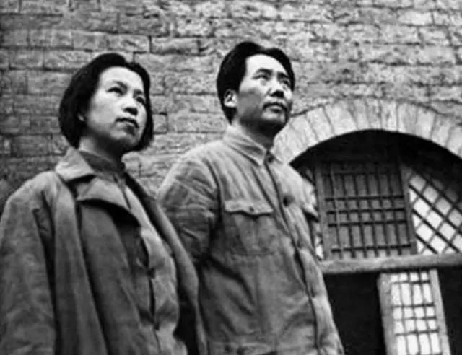
Chairman Mao Zedong and Comrade Jiang Qing in the Yan’an base area.
Vizcatán: The Difficult but Glorious Road of the Revolution

That red flag of the gringo Jack and his assistant was clearly engraved in my mind. That chant, rough and powerful, that they intoned, was engraved in my mind. I set myself a purpose: to investigate the meaning of that flag and the solemn chant. As the months and years went by, the panorama opened up and I came to understand it all, which was extremely thrilling.
That red flag, unfurled by the gringo Jack and his assistant, had already flown defiantly before the bourgeois world over the Hôtel de Ville, as a symbol of the Republic of Labor with the Paris Commune, the most heroic feat of those workers ready to storm heaven, in the words of the greatest thinker of the centuries, Karl Marx, in 1871.
This same flag was upheld by the workers in the streets of Berlin, Milan, London, Madrid, Paris, Chicago, and the whole world. This same flag was upheld victorious in October 1917, in the city of Petrograd, in the hands of the Bolsheviks, proclaiming all power to the soviets and the birth of the Republic of Workers and Peasants, the dictatorship of the proletariat, with Vladimir Ilyich Ulyanov Lenin and Joseph Stalin. This same flag, defiant before the wind, flew undaunted in the Autumn Harvest Uprising, in the Jinggang Mountains, in Yan’an; in the streets of Shanghai during the Great Proletarian Cultural Revolution, marching at the head of it all, Chairman Mao Zedong and with him, Jiang Qing, Zhang Chunqiao, Wang Hongwen, Yao Wenyuan and the proletariat of the Chinese people. This same Red Flag has been unfurled in the wind in our homeland, Peru, since October 7th, 1928, with José Carlos Mariátegui. It had to go through a hard period of abandonment and reconstitution to be hoisted on the back of the Andes of Peru, since the year 1980, rightly called ILA-80. This same flag, finally, today flies victorious in the glorious and warrior Vizcatán, so that no one can lower it, or write in the opposite direction. Moreover, to keep it always unfurled at the cost of our lives.
Conversations with Comrade Laura...

Today we uphold, defend, and apply our undefeated flag: Marxism-Leninism-Maoism, Gonzalo Thought. We can serve nothing else. With Chairman Mao, we learned to know Peru. His work and thought have deeply marked the minds and hearts of the communists in our homeland and, with it, illuminate the sun of the revolution forever and ever. Chairman Gonzalo is the heir of Chairman Mao Zedong, with him Maoism shines as the third, new, and higher stage of Marxism, in hard struggle, which entails upholding it, defending it, and applying it. Let’s get to work!
Let us return to Broad and Alien is the World. That solemn, “rough and powerful” song was The Internationale, the highest and most sublime song, the most beautiful song of the working- class, a song created by Eugéne Pottier, which today is sung proclaiming the final struggle for Communism, the unalterable goal of humanity.
This chant, “rough and powerful,” that is The Internationale and the red flag, which flies defiantly before the bourgeois world, has plunged into terror and convulsions of rage, turning the gloomy nights of the reactionaries of Peru, of imperialism and revisionism, into a nightmare. Instead, it has summoned the resounding war cry of the working-class that with fist raised, marches uncontainably to its final goal, Communism.
I sincerely believe that our concerns about the red flag and the “rough and powerful” song of the gringo Jack and his assistant have been resolved. We definitely delved into the study of Marx, Lenin, and Chairman Mao Zedong, we met Mariátegui . . . and we had Chairman Gonzalo in Peru.
Vizcatán: The Difficult but Glorious Road of the Revolution

“Comrade, How Do You Organize Study in Vizcatán? What Other Books Left an Impression on You?”

Because of our obligation as communists, we study books by Marx, Engels, Lenin, Stalin, Mao Zedong, José Carlos Mariátegui, and the Party documents. Our life is a constant fight. We would like to dedicate more time to study, but time is short and our time is as a highly mobile guerrilla. Still, there is time to read. Nikolai Ostrovsky’s How the Steel Was Tempered is another book, recommended for young proletarians. We too have many comrades in the style of Pavel Korchagin, courageous to the point of sacrifice, upright and disciplined in the line of duty. If our flag is red, it is soaked with the blood of those who offered blood and will continue to offer blood, to continue to sustain it . . . and ours will unite a bit more to keep it always alive, always burning, always shining.
In this unparalleled fight to achieve a new world, I have seen my comrades leave for battle, with the same enthusiasm as always; if any of them did not return, it was because, as they had always done, they gave their commitment to fight, they already belonged to history. Then we gathered in a solemn ceremony and reaffirmed our commitment to fight to the last drop of blood and give up our lives for the Party and the Revolution, as we have already demonstrated and are demonstrating repeatedly and as many times as necessary. Our entire contingent, en masse, makes its resounding war cry heard: “Glory and Honor to the Heroes of the People!” “Long Live the Revolution!” Only once, I felt the spasm of the gallows on my neck, in Tsomaveni, in the hands of the enemy. Only courage and decisiveness changed this fatal episode. Then, I clearly remembered the swaying body of Valya Bruzzhak, of Rosa Gritsman . . . Would I march to the scaffold, singing as they did? Yes, I would. But
Conversations with Comrade Laura...

remember, words are one thing, deeds are another. Dare and the problems will be solved. This book, too, goes with me, boosting morale and giving courage and optimism.

“Many Intellectuals Have E⁠xpressed Different Opinions About the Subversion in Peru. What Do You Think About This?”

In Peru, through different newspapers, magazines, radio, and television, different people have been expressing themselves. You should know them by their fruits. Some do so with great rage against the Party and the Revolution. They are right, they are defenders of the established order. The hair has to defend the skin, otherwise what could they adhere to? For them, Peru is composed of the big bankers, the big landlords, the big bourgeoisie, and all kinds of leeches that suck the blood of the people. They consider themselves great defenders and even representatives of the people. Of course they want them, otherwise, where does the surplus-value, the profit of the rich, come from? The bourgeois intellectuals demonstrate their spiritual poverty by defending the system they parasitize, which is why they detest everything that concerns the profound transformation of a society and above all when it is done through a revolution, through armed struggle. For example, that gentleman who expresses in his own face the aberration, the distress and misery of the bourgeois class, author of that babelic and bastard publication called Prophets of Hate, who without the slightest embarrassment and with the utmost brazenness of a parasite of the system, after so much absurd and senseless imagery, referring to Chairman Gonzalo, states:
Vizcatán: The Difficult but Glorious Road of the Revolution

(…) From this perspective these people should be condemned in the harshest terms, since the damage they did to Peruvian society is immense (…) There is no person who has produced more deaths and suffering in recent Peruvian history (…)

When this tool refers to Peruvian society, he is talking to us about Peruvian society as a system, this society is that of the big landlords, the big bankers, the big bourgeoisie in its two factions: comprador and bureaucrat; it is the voice of American imperialism, mainly.
Here it is worth asking: Is it not this reactionary state of Peru that preaches the peace of the starving? In the world, three-quarters of humanity are submerged in hunger, in misery, because of the imperialist system. In Peru, because of the only prevailing system, 60,000 children die every year before their first birthday, according to Lima newspapers. Can we compare the officially reported deaths in the war between revolution and counter-revolution? The deaths in the war, in more than twenty years, do not exceed the death of minor children due to starvation; even though the immense majority of the deaths are a consequence of the genocide to which the Peruvian people were subjected by the armed forces and police.
This heartless author of Prophets of Hate says: “(…) [for] the damage they did to Peruvian society is immense (…)” Simply answer these questions: Who destroys the productive forces of a nation in formation like ours? Who forbids the peasantry to work the land with instruments discarded by history hundreds of years ago? Who squeezes the proletariat dry for a miserable wage? Who generates unemployment, the rising cost of living, and appalling working conditions? Who generates the crisis that grinds the people and sweeps away small and medium-sized businesses? Who squanders our wealth for paltry payments, plundering the sea, depleting the countryside, closing mines,
Conversations with Comrade Laura...

destroying rainforests, and drowning cities in misery? Who drowns the nation with colossal debts, subjugating us further? The answer is: the Peruvian state of the landlords, the big bankers, the big bourgeoisie in its two factions: comprador and bureaucratic, lackey of American imperialism, mainly.
It is not enough to cause damage to this society, it has to be overthrown, swept away, demolished, eradicated. And on its ashes, on its rubble, to build, the thriving, the springtime, the unfading People’s Republic of Peru; a Republic of Workers and Peasants and, finally, a society without rich and poor, a society of eternal harmony, Communism.
On the “deaths” and “suffering”: we have demonstrated ad nauseam that faithful to our convictions we give our lives for our ideal which is the classless society, it is the cost we pay without any hesitation. We stand by our actions. We are class fighters. But hasn’t the current system — the society that this parasite defends — once again plunged the Peruvian people into the most appalling misery, malnutrition, hunger, children dying before the age of two, even murdered in their mother’s womb, genocide, brutal repression, torture, forced disappearances, mass graves, concentration camps, etc.? All of this is the work of this system, of this society. And of course, we must sweep this away, as is fitting, throughout the land. Consequently, Prophets of Hate is nothing more than a tribute to vulgarity, stupidity, and arrogance.
Vizcatán: The Difficult but Glorious Road of the Revolution

“Clarify for Us a Little About the Concept of Revolution That the Communist Party of Peru Has.”

We refer to the Party documents and to the theory and action of the teachers of the working-class: Marx, Engels, Lenin, Stalin, Mao Zedong, and, of course, José Carlos Mariátegui. However, with the patience that characterizes us and as part of our duty to organize and educate we would like to remind you of the concept of revolution:

Revolution is not an idyllic apotheosis of Renaissance angels, but rather the tremendous and painful battle of a class to create a new order. No revolution, neither that of Christianity, nor that of Reform, nor that of the bourgeoisie, has been accomplished without tragedy. The socialist revolution, which moves men to fight without extraterrestrial promises, which asks of them an extreme and unconditional surrender, cannot be an exception in this inexorable law of history. The anesthetic, paradisiacal revolution has not yet been invented, and it is indispensable to affirm that man will never reach the summit of his new creation except through a difficult and painful effort in which pain and joy will be equal in intensity.
— The Morning Soul,
José Carlos Mariátegui.

A revolution is not a dinner party, or writing an essay, or painting a picture, or doing embroidery; it cannot be so refined, so leisurely and gentle, so temperate, kind, courteous, restrained, and magnanimous. A revolution is an insurrection, an act of violence by which one class overthrows another.
— Selected Works, Vol. I,
Mao Zedong.
Conversations with Comrade Laura...

Revolution: (lat. Revolitio, -onis): Abrupt and violent change in the social or political structure of a state, generally of popular origin: the revolution of 1868. 2. Fig. Total and radical change, complete transformation (…)
— Larousse,
Dictionary Encyclopedia, 2003.

The Larousse dictionary very clearly states: “abrupt and violent change in the social and political structure of a state (…)” attention! . . . “ (…) generally of popular origin.” Of course, only the people make the revolution, it is the direct interested party. Why does Larousse say: “generally”? Because it believes that the pronouncements of the bourgeoisie about revolution are also a profound change. As they called the government of Velasco Alvarado. As many others boast when pronouncing the word revolution. What the bourgeoisie does is readjust its regime of exploitation when it is threatened. But, this act of readjusting and maintaining itself in the power of the ruling classes, is nothing more than lip service. The bourgeoisie has reached its highest and last stage: imperialism; it is struggling in the midst of a great crisis, so the time has come to bury them, this can only be done through the People’s War led by the Communist Party. Imperialism must be completely and utterly destroyed. The reason is that it is a system of oppression and exploitation, therefore, it corresponds to say “It is right to rebel,” class struggle, and revolution.
To the intellectuals of Peru we say: reorder your way of thinking and put the word revolution on the agenda. Class limitations cannot be an excuse to be accomplices of the ignorance and spiritual poverty of the ruling classes. We cannot continue to be intellectuals of the pantheon; let us put our thinking in motion.
Vizcatán: The Difficult but Glorious Road of the Revolution

After all, it is not simply a matter of rearranging our thinking, it is a problem of class position. If I take a position for the people, then from there I will fight. Remember that the reactionaries will never put down their butcher’s cleaver, until their final ruin.
The renowned historian Jorge Basadre, in some part of his book called Peru: Problem and Possibility,4 in his commentary on Socialism, states with complete certainty:

(…) It will take time, it will suffer defeats and betrayals, it may or may not be preceded by previous stages; but socialism will come (…) With socialism, the laborious process of Peru’s historical formation must culminate. Within it, linked more than ever to the continent and to humanity, Peru must find its reality and its solution.

When speaking of the so-called stages prior to Socialism, Dr. Jorge Basadre refers to the Democratic Revolution, or Revolution of New Democracy, in the style of Chairman Mao Zedong. This stage prior to Socialism in Peru was already established by the Chinese Revolution and is clearly sustained in the Programmatic Principles of the Socialist Party, printed in the pages of José Carlos Mariátegui’s Ideology and Politics. In Peru, the construction of this stage prior to Socialism began
in 1980. And if we go a little further, since the founding of the Party of the working-class. This grandiose process of the history of Peru must conclude with the establishment of the People’s Republic of Peru: first, a New Democracy; then, in an uninterrupted manner, the construction of Socialism and then, successive cultural revolutions to maintain the dictatorship of the proletariat, to maintain the course and prevent capitalist restoration, finally Communism, the reign of eternal harmony. A

4Perú: Problema y Posibilidad. — PFP
Conversations with Comrade Laura...

classless society, without exploiters or exploited. The humanity of Labor. This unfading goal, which is Communism, is to be reached through the People’s War, led by Communist Parties and with Marxist-Leninist-Maoist, principally Maoist, ideology in the countries of the entire Earth. In addition to all this, it is worth studying what Dr. Basadre said: “Those who only take solace in the past, ignore that Peru, the real Peru, is still a problem. Those who fall into bitterness, into pessimism, ignore that Peru is still a possibility. Peru is indeed a problem, unfortunately, but also, happily, a possibility.” Let us raise our eyes to what is happening in the Peruvian Andes and we can already glimpse the future birth of the People’s Republic of Peru.
Since 1990, a book called When Did Peru Go Wrong?,5 published by Milla Batres, has been circulating. The opinion of different characters, very renowned by the way, is extremely important. From the most rabid against the Party and the Revolution, to intellectuals who simply evade their responsibility by diverting their attention and hiding behind the supposed paradise of our historical past, such as, for example, the Tahuantinsuyo. They make brilliant statements and analyses of the glorious past and the current crisis, but concentrate their hope in the so-called “democracy.” They hope some genius will emerge with his magic wand to change the so-called corruption, exploitation, the blatant theft of state funds, etc. But, this book also offers the lucidity and sensible opinion of a highly prestigious intellectual, Professor Washington Delgado. It presents a well-founded analysis of the process of development of Peruvian society; it is true that we disagree with him in several of his statements, however, we appreciate his writings. The professor states: “(…) Sympathy, admiration, hatred, or fear do not allow a serene, impartial, objective judgment about the Shining Path.”

5En Qué Momento se Jodió el Perú? — PFP
Vizcatán: The Difficult but Glorious Road of the Revolution

With all due respect to Professor Washington Delgado, allow us to say that the exact denomination of who is leading the People’s War is the Marxist-Leninist-Maoist, Gonzalo Thought, Communist Party of Peru. And, on the so-called impartiality, it can only be affirmed that in Peru there are two clearly defined currents, parties, or contenders: on the one hand, the reactionary state of Peru, which was born in 1821; and, on the other, the Peruvian People, peasants, workers, petty- bourgeoisie, and even the national bourgeoisie, led by the Communist Party of Peru, which strive to establish the People’s Republic of Peru. As for the so-called legal left, it can only be affirmed that, in one way or another, it is on the tail of the governments in power, receiving crumbs and scheming to oppress and exploit the Peruvian people — an example, Red Homeland [Patria Roja],6 no doubt about it.
The final paragraphs of this commentary are extremely sensible, I believe, for the reflection of the rabid defenders of order. Professor Washington Delgado concludes:

(…) In the light of this analysis it is clear that the ruling classes and the governing political parties of Peru have not known how to approach the Shining Path phenomenon adequately and have limited themselves to seeking a military solution, that is to say, they have followed the same conduct of the Inspector Areche and the viceroyalty government. Evidently, history has taught us nothing. The Shining Path is not a disease of Peru, it is the symptom of a disease. The root of its violence lies in the atrocious pauperization of the provinces and the countryside. That is the disease that must be remedied.7

6Communist Party of Peru–Red Homeland — “(…) [A]n agent of Chinese revisionism whose party hacks worship Deng.” El Diario, Interview with Chairman Gonzalo (Kansas City: Prairie Fire Publishing, 2025), p. 23. — PFP
7Emphasis added by Comrade Laura. — PFP
Conversations with Comrade Laura...

“[T]he same conduct of the Inspector Areche and the viceroyalty government.” Please remember the massacres of Cayara, Accomarca, Uchuraccay, Llocllapampa, Bellavista, Huancaraylla, Pomatambo, Pucayacu, Putis, Remillapata, Barrios Altos, La Cantuta, El Frontón, Lurigancho, Santa Bárbara, Canto Grande, the concentration camps of Asquipata, Totos, Castropampa, Pichari, Pampa Cangallo, and Los Cabitos. Just to mention a few.
Our commentary: The viceroyalty state represented by Viceroy Jáuregui, Inspector Areche, Oidor De la Mata Linares, Bishop Moscoso, have exercised a barbaric genocide against the so-called “rebellious Indians.” Finally, they have not prevailed, because the viceroyalty state was buried in the middle of incessant fights, at the cost of the life and blood of the Indians, to give birth to a new state, new in its time, which we know it as the Peruvian Republic, of a liberal-democratic nature. This republic, in almost 200 years, is the one that has reached its final stage in the midst of its generalized crisis.
Marxism-Leninism-Maoism, Gonzalo Thought, teaches us that the bloody birth of the Revolution is, in the end, much less painful than the chronic suffering in the old society. We want to remind you: widespread corruption, children dying before their second birthday from hunger, high taxes, miserable wages, food shortages, delinquency, prostitution, drug trafficking in the upper echelons of Peruvian society, plundering of our wealth by imperialism, disappearances, genocide, torture, concentration camps, etc.
Let us enlighten ourselves a little. The German Rudolf Kjellén, a pioneer of geopolitics, which as such arose in 1916, that is, during World War I, has published his book: The State as a Lifeform. In this book he argues that “the state is a biological organism (…) that is born, grows, and dies in the midst of
Vizcatán: The Difficult but Glorious Road of the Revolution

permanent struggles.” This among many other things. In merit of this affirmation we can conclude: Where have the slave states of Greece and Rome gone? The answer is: they have passed away and belong in the museum of history. Where are the feudal states of Europe, for example, that of Louis XVI? Also in the dustbin of history, as the refuse of society. Many states that are unjust, that are exploitative, have collapsed in the midst of irremediable contradictions, to give way to a new one. Where is the Inca state called Tahuantinsuyo? Buried. Only its constructions are left for the museum of history. Some still dream of reviving this corpse. They are vain dreams. The wheels of history do not turn back. Where is the once powerful and extensive viceroyalty state? We all know. The wars of independence, culminating in the battles of Junín and Ayacucho, buried it. But, at present, mainly the governments in power, all the imperialists, mainly American imperialism, the revisionists and their cronies, clamor and shout loudly: “This democracy is eternal and no one will be able to change such a marvel.” What reasons do they have? None. Simply, their end is near. Their grave is dug. They themselves have dug it and have also created their gravediggers.
Social revolutions in the different stages of human history are historically inevitable and governed by objective laws independent of man’s will. History has demonstrated, in repeated opportunities, in an irrefutable way, that there has not been any revolution that has reached triumph without having traveled a road that was tortuous, difficult, and without sacrifice. Ours could not be an exception. Sacrifice was always present. In the revolution of the slaves; in the revolution of the serfs; in the bourgeois revolutions; in the national revolutions. And, with greater reason, in the last battle waged by the working- class to establish New Democracy, Socialism, and a classless society: Communism. What Chairman Mao Zedong said has universal validity:
Conversations with Comrade Laura...

How different is the logic of the imperialists from that of the people! Make trouble, fail, make trouble again, fail again . . . till their doom; that is the logic of the imperialists and all reactionaries the world over in dealing with the people’s cause, and they will never go against this logic. This is a Marxist law.
Fight, fail, fight again, fail again, fight again . . . till their victory; that is the logic of the people, and they too will never go against this logic. This is another Marxist law.
— Mao Zedong, Selected Works, Vol. IV.

We only want to warn you: The present state will not prevail either. Surely the People’s Republic of Peru will be established and we will reach the reign of eternal harmony, Communism. The rest, weather and time . . .
In the meantime, struggle, fight, resist. It is good to remember what the Party always keeps in mind: Our center is to fight. Our base is the proletariat and the people. Our road is the People’s War. Our objective is the People’s Republic of Peru. Our ideology is Marxism-Leninism-Maoism, Gonzalo Thought. Our final goal is the World Proletarian Revolution and Communism.

“Comrade, Are There Any Special Dates That the Party Celebrates?”

Of course, we can mention a few: May 1st — International Workers’ Day, commemorating the events in Chicago, for the blood shed by the workers and the achievement of the eight- hour workday. May 17th — initiation of the armed struggle in Peru, ILA-80. June 14th — birthday of José Carlos Mariátegui. June 19th — Day of Heroism, in honor of the martyrs of El Frontón, Lurigancho and Santa Bárbara, and Chorrillos.
Vizcatán: The Difficult but Glorious Road of the Revolution

October 4th — Prisoner of War Day. October 7th — Day of the Foundation of the Communist Party of Peru. December 3rd — Chairman Gonzalo’s birthday and People’s Liberation Army Day. December 26th — Chairman Mao Zedong’s birthday, representing the highest expression of the ideology of the proletariat: Maoism.

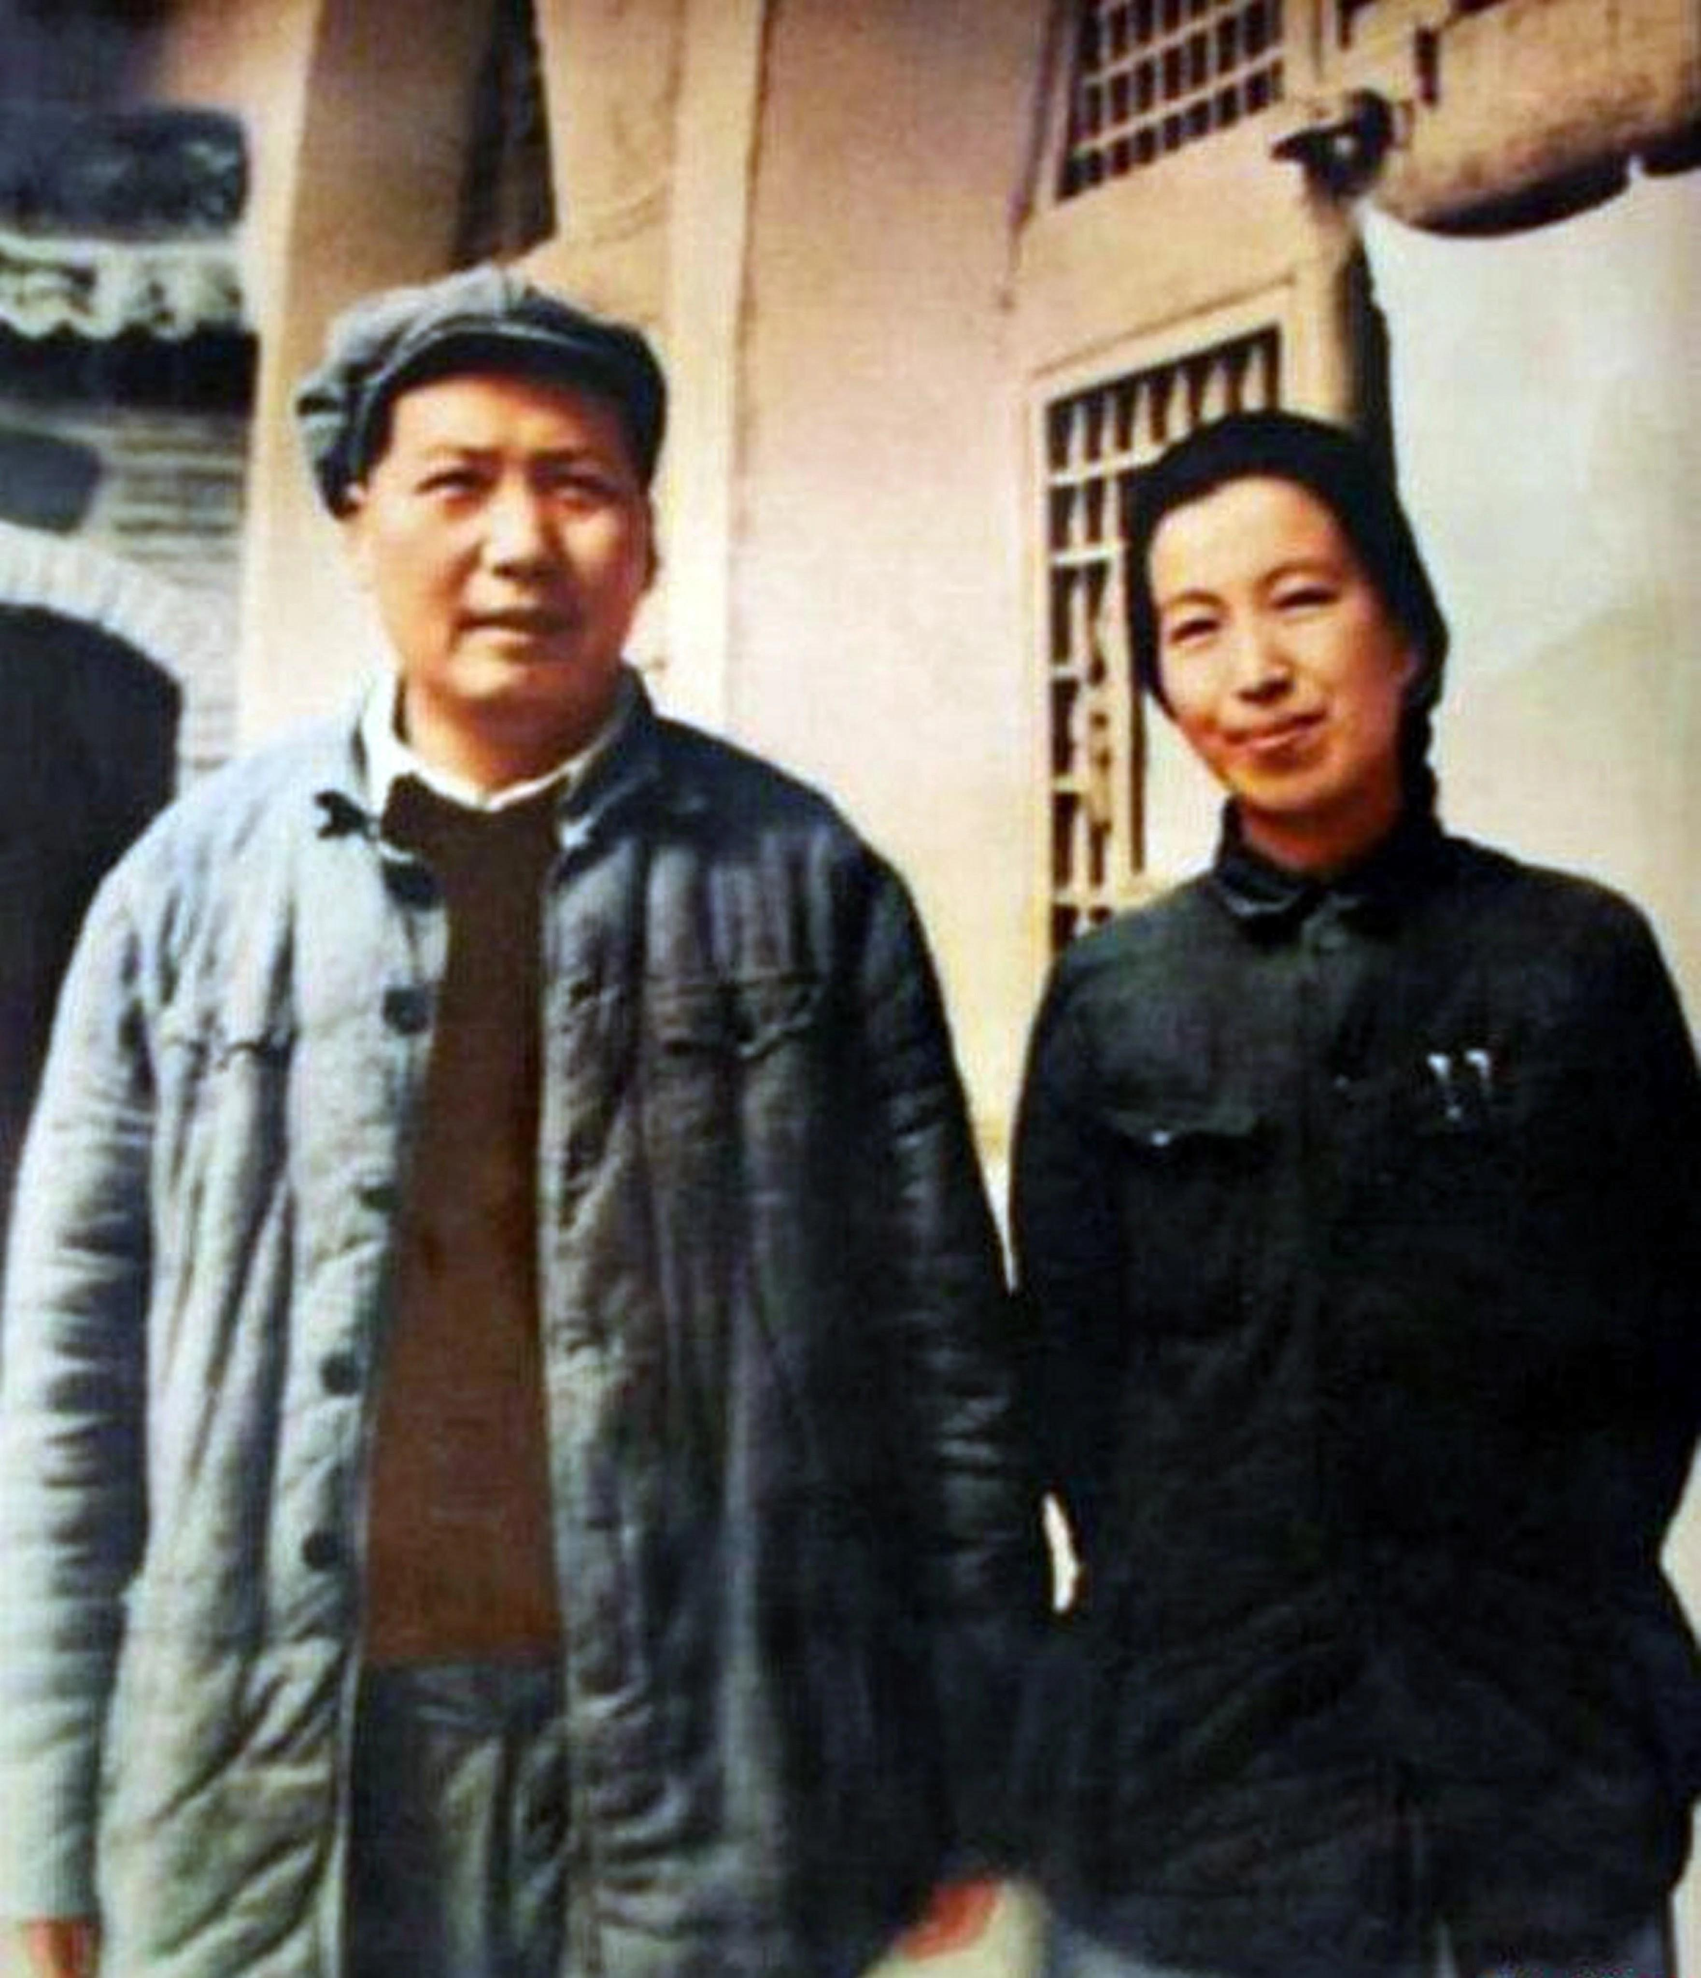

Picture taken at the Yan’an Base Area. Chairman Mao Zedong and Comrade Jiang Qing. Flag-bearers of the Great Proletarian Cultural Revolution. Maoism, the third, new, and higher stage of the ideology of the proletariat.
Conversations with Comrade Laura...

“We Would like Your Thoughts on Dr. Abimael Guzmán Reinoso8 and Augusta La Torre Carrasco.”9

Dr. Abimael Guzmán Reinoso, Chairman Gonzalo, born on December 3rd, 1934, in Mollendo, Islay. In his youth he was affected by the fierce class struggle in his home department of Arequipa and by the events of World War II. He openly and consciously sought and achieved Party membership. Tenacious and consistent in the struggle against revisionism, he had the opportunity to fight Khrushchev’s revisionism at the international level and the revisionism of Jorge Del Prado until expelling him at the Fourth Conference in January 1964.
He undertook the reconstitution of the Communist Party of Peru, until then burdened by an electoral and capitulationist line. His proposals for the “Reconstitution of the Party” and the “creation of the armed force” were realized; previously he fought an arduous battle against lines contrary to Marxism, such as the opportunism of the Red Homeland [Patria Roja] that denied the revolutionary situation and Chairman Mao Zedong, instead becoming worshippers of Deng Xiaoping; against the liquidationism of Saturnino Paredes10 and the left- liquidationism of Sergio’s self-styled “Bolshevik” group, and at the Ninth Plenum he fought against a right-opportunist line that opposed the initiation of the armed struggle.
Chairman Gonzalo worked tirelessly for the reconstitution of the Party, as a Party of a new type, a Marxist-Leninist- Mao Zedong Thought Party, as it was called at that time. He endowed it with a just and correct ideological and political

8Chairman Gonzalo, Leader of the Party and the Revolution. — PFP
9Comrade Norah, the greatest heroine of the Party and the Revolution. — PFP
10Saturnino Paredes was a Hoxhaite and leader of the revisionist “Peruvian Communist Party (Marxist-Leninist).” — PFP
Vizcatán: The Difficult but Glorious Road of the Revolution

line and in the furnace of the class struggle he forged the historical contingent that assumed the initiation of the armed struggle, ILA-80. He fought hard until the reconstitution was completed, as a great teacher of communists, continuator and heir of Marx, Engels, Lenin, Stalin, Mao Zedong, and José Carlos Mariátegui; he guided the Party, step by step, along the difficult but glorious road of encircling the cities from the countryside, to build a New Democratic State. The most magnificent achievement, as the highest expression of the development of matter, was the historic First Congress, the Marxist-Leninist- Maoist, Gonzalo Thought Congress, which set the road to follow until the triumph of the class. For the international proletariat, it proclaimed Maoism as the third, new, and higher stage of Marxism, transforming the ideology of the proletariat into Marxism-Leninism-Maoism.
In the harrowing and ardent class struggle and in leading the People’s War in Peru, the ideology was elevated to Marxism- Leninism-Maoism, Gonzalo Thought, key to the development of the World Proletarian Revolution, and in Peru, to the conquest of power. The People’s War burns victorious in the Peruvian Andes, an inextinguishable fire that will guide us to the ever- luminous and reborn Communism. Chairman Gonzalo (and excuse me for being so repetitive, it must be said as many times as necessary), he is the continuator and heir of Marx, Engels, Lenin, Stalin, Mao Zedong, and José Carlos Mariátegui. A great communist militant and fighter, his thought and work are imperishable. Extraordinary man whose life continues to the end, with the unfading light of Marxism-Leninism-Maoism, Gonzalo Thought, with the omnipotent creative force of the masses. In homage to his complete and total dedication to the Revolution, December 3rd, the date of Chairman Gonzalo’s birth, is People’s Liberation Army Day and as such already shines in history.
Conversations with Comrade Laura...

About Comrade Norah, the Party has declared: The greatest heroine of the Party and the Revolution! An example of self- sacrifice, a consistent anti-revisionist. Companion, Comrade, and wife of Chairman Gonzalo.
. . . Just a moment! . . . You want a documented opinion of the Party about Dr. Abimael Guzmán Reinoso . . . this is our assessment of Chairman Gonzalo, Leader of the Party and the Revolution, the greatest living Marxist-Leninist- Maoist, Gonzalo Thought on Earth; also about Comrade Norah. (Comrade Laura takes a notebook out of her bag and reads):

The First Congress of the Communist Party of Peru, the Marxist-Leninist-Maoist, Gonzalo Thought Congress has declared Comrade Norah: “The greatest heroine of the Party and the Revolution!” As such, it has issued the following statement:

SPECIAL RESOLUTION
Honor and glory to Comrade Norah!
The First Congress pays deep and solemn homage to Comrade Norah, member of the red fraction and proven communist, great leader and everlasting example of giving her life for the Party and the Revolution, untiring Marxist-Leninist-Maoist, Gonzalo Thought fighter, firm and consistent anti-revisionist, the greatest heroine of the Party.
The Congress decorates her with the order of the hammer and sickle, the highest Party distinction, and decides that in the future monument to the heroes of the people, she will be placed in a special and highly favored location.

First Congress, Communist Party of Peru,
June 29, 1989.
Vizcatán: The Difficult but Glorious Road of the Revolution

Honor and glory to Comrade Norah!
Firm Marxist-Leninist-Maoist, Gonzalo Thought, anti- revisionist, founder of the red fraction and great historical leader: example of giving her life for the Party and the Revolution; daughter of the people and the international proletariat. Flaming red flag defiant against the wind.
The greatest heroine of the Party and the Revolution!

Gonzalo,
Peru, March 8, 1991.

Chairman Gonzalo, the greatest man of the present era, leader of the Party and the Revolution. The Peruvian people, in glorious years of combat and victories, march unstoppably to the conquest of power in the entire country. He has established the People’s Committees, expressions of the New Power, developing the war of movement. Chairman Gonzalo is leading our entire work, our entire struggle. You ask yourselves, who is Chairman Gonzalo? He is the new leader of heroic deeds, teacher of teachers, great among the great, he is the eagle of our Party. Look at him in these years of triumphant Revolution, look at how he forms communists in his image and likeness, how he forms iron legions ready to weather all storms, how he builds brick by brick the New Power. It is right to rebel. What do we have? Nothing. What do we want? Everything. We want a new, communist society. Without rich or poor. A society of eternal harmony. Chairman Gonzalo guarantees this. Upholding, defending, and applying Marxism-Leninism-Maoism, Gonzalo Thought. The People’s War in Peru ignites bright hopes. Embody Gonzalo Thought!
Ayacucho Zonal Committee, Communist Party of Peru,
1990.
Conversations with Comrade Laura...

This paragraph is a part of the manifesto of the whole Party. For us Gonzalo Thought is of primary importance, it is the application of Marxism-Leninism-Maoism, principally Maoism, to the revolution in backward, semi-feudal, and semi- colonial countries, such as ours. At present it is being ignored as a consequence of a right-opportunist line, disguised as left, which is the current leadership. Otherwise, how can we explain their attitude of: denying the Marxist-Leninist-Maoist, Gonzalo Thought First Congress?; labeling the Lucanamarca action as “terrorist”? What is the difference of opinion between the opportunists and the reactionary government of Peru regarding Lucanamarca? None. Can there be so much coincidence? Obviously it is a pernicious line that undermines the Revolution.
To praise the reactionary government of Hugo Chávez in Venezuela, Evo Morales of Bolivia; to praise the government of Fidel Castro, with the argument that “they are, somehow, on the road to Socialism”; disowning Maoism, supposedly “for not building the Fourth International,” yearning for Che Guevara, the already defeated focoism, by assigning military ranks to the combatants of the People’s Liberation Army, the commandantism, in its black attempt to build an army with a bourgeois military line, “every army in the world is made up of men . . . women are a complement.” To call for the death of Chairman Gonzalo, which would be a colossal assassination, a treacherous stab in the back to the working-class. All these problems have to be solved in a hard two-line struggle, in the midst of the storm of revolution, which we are already waging.
Vizcatán: The Difficult but Glorious Road of the Revolution

“Many Intellectuals Have E⁠xpressed Their Opinion on Chairman Gonzalo, Some Even Coming Against Him and Condemning Him. What Do You Have to Say About This?”

Just as there are bourgeois intellectuals . . . reactionaries, there are also very brilliant intellectuals, worthy of being called that, men of broad imagination, capable of understanding and grasping the historic moment that we are living in, and giving the place that corresponds to Dr. Abimael Guzmán Reinoso, Leader of the Revolution and Chairman of the Communist Party of Peru.
The Peruvian people, the international proletariat, have already given their opinion. History, an irrefutable judge, has also given its verdict, and in the pages of our history, Chairman Gonzalo is the most outstanding man of the Great March of the Peruvian Revolution, and his name will be stamped next to that of Marx, Engels, Lenin, Stalin, Mao Zedong, and José Carlos Mariátegui . . .
The voice of Dr. Abimael Guzmán Reinoso: “Uphold, defend, and apply Marxism-Leninism-Maoism, Gonzalo Thought,” “Strive for Maoism to be the command and guide of the World Proletarian Revolution” and “Long live Maoism,” is for us the battle cry of the working-class and the peoples of the world to end slavery on Earth.
In these circumstances it is worth noting an intellectual production worthy of appreciation, The Generation of 1950: A Divided World,11 by the literary master Miguel Gutiérrez, in which he states:

11La Generación del 50: Un Mundo Dividido. — PFP
Conversations with Comrade Laura...

Abimael Guzmán would be a unique case among revolutionary intellectuals who access Marxism, not for ethical reasons, as an existential search or as a cathartic therapy to conjure certain obsessions, but in a rational way, after waging a flaming contest in his spirit between idealism and materialism (…) What else can be said about Abimael Guzmán? (…) His indifference to the cheap fame for which so many intellectuals strive, and his austere life, a very austere life, all this behavior, all this attitude, configures a different intellectual of a new type, flamed by a unique and absolute passion — flame, fire, bonfire, blaze — ignited by the critical and radical development of thought (…) Abimael Guzmán and Comrade Gonzalo are the same person, so the one who has been leading this great historical event is a man of higher intelligence, of unbreakable will and discipline, and that if the militants accept his leadership, they do not do it by authoritarian imposition, but by the correctness of his thinking and the coherence between his being and thinking.
Chairman Gonzalo is a child of the Party and the Revolution. A life fully and completely dedicated to the Party and the
Revolution. We can only reiterate: Thank you Chairman, your encouragement, your life, and your work unfadingly and undyingly pulses in us.
Dr. Miguel Angel Rodriguez Rivas, lecturer at the Center of Advanced Military Studies (CAEM) said:

He was one of the best students of an era that was characterized by having brilliant students, Abimael was a theorist of the highest level. Arequipa has been poor in many things, except in producing men. Guzmán is one of them. I believe that, in Peru, his level is next to Mariátegui.
Vizcatán: The Difficult but Glorious Road of the Revolution

Dr. Luis Guillermo Lumbreras, author of The Origins of Civilization,12 and a professor at the University of Huamanga at that time, has the following recollection:

A brilliant man, a great debater; possessor of precise rhetoric, spoke in short sentences, which always contained something specific. As a teacher, he was brilliant, an excellent speaker, not so much in writing; while speaking he was fluent and extremely rigorous (…) he was very disciplined and orderly, not very prone to idleness, he was always looking for what to do and talking about what had to be done.

Dr. Efraín Morote Best, president of the National University of San Cristóbal de Huamanga13 during Abimael’s stay in
Huamanga, says:

Peru has rarely seen a man of the intelligence and stature of Dr. Guzmán. Along with his high intellect, he was a simple person, full of virtues, of solid ideas and convinced of the revolutionary changes that were in store for Peru, a personality like no other, worthy of appreciation (…) As a man he was always sensible and worthy of appreciation; as an intellectual and teacher, of admiration and respect, both for the breadth and solidity of his knowledge and for the ability to adhere to postulations contrary to his own (…)
On our part, thank you, Dr. Morote!
Even, a colorful character, at that time close to the Party, a tenacious opportunist, electioneer, known client of the Peruvian parliament, worshipper of his likeness the sinister and dwarfish Deng Xiaoping, Comrade Eco, Rolando Breña, in Red Homeland

12Los Orígenes de la Civilización. — PFP
13Universidad Nacional San Cristóbal de Huamanga. — PFP
Conversations with Comrade Laura...

[Patria Roja], cannot hide the historical truth and has dared to express his opinion about Chairman Gonzalo, when he says:

(…) As an intelligent person; cultured, prepared, studious, skillful, with a great conviction of what he does and with tremendous capacity to expose issues and convince people. Another virtue is his dedication to political and party work.

The seizure of power by armed force, the settlement of the issue by war, is the central task and the highest form of revolution. This Mar⁠xist-Leninist principle of revolution holds good universally, for China and for all other countries.
— Chairman Mao Zedong

The seizure of power by armed force, the settlement of the issue by war, is the central task and the highest form of revolution. This Mar⁠xist-Leninist- Maoist, Gonzalo Thought principle of revolution holds good universally, for Peru and for all other countries.
— Central Committee, PCP
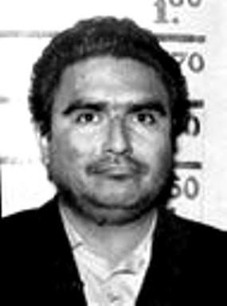

Dr. Abimael Guzmán Reinoso, Leader of the Communist Party of Peru, Great Marxist-Leninist-Maoist, Gonzalo Thought.
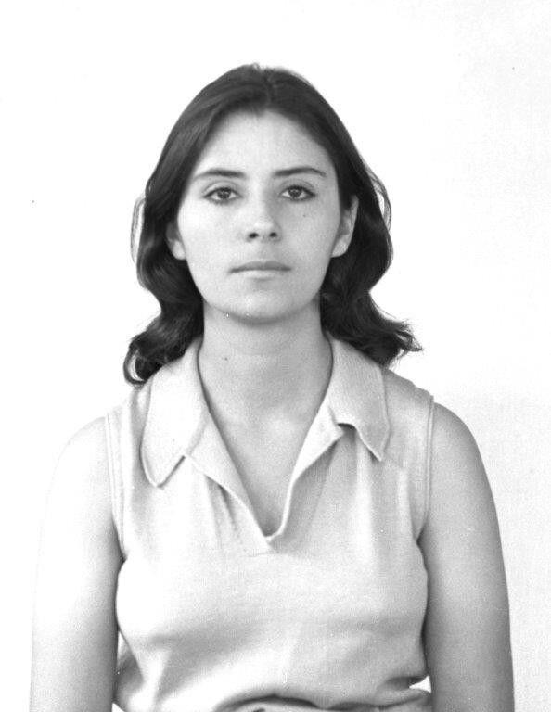
Augusta La Torre Carrasco, Comrade Norah, communist combatant, companion and comrade of Chairman Gonzalo. Honor and Glory!
Vizcatán: The Difficult but Glorious Road of the Revolution

“Tell Us Something about What Occurred in Lucanamarca and Its Implications.”

I was not there on that occasion because I was only ten years old. According to Party documents, the action at Lucanamarca is clearly framed within what Lenin rightly established, when in the article Lessons of the Commune, published on March 23rd, 1908, he adamantly states: “(…) [the proletariat] must never forget that in certain conditions the class struggle assumes the form of armed conflict and civil war; there are times when the interests of the proletariat call for ruthless extermination of its enemies in open armed clashes.” The cowardly bourgeois intellectuals are right to rage against the ideology of the proletariat. When the time comes, the sword must be wielded with a firm hand to preserve, seize, maintain, and advance.
The voice of the Party and the Revolution on the action at Lucanamarca, timely, clear, and forceful, was expressed by Chairman Gonzalo:

The struggle was intense and hard, those were complex and difficult times.
In the face of reactionary military actions and the use of mesnadas, we responded with a devastating action: Lucanamarca. Neither they nor we have forgotten it, to be sure, because they got an answer that they didn’t imagine possible. More than eighty were annihilated, that is the truth. And we say openly that there were excesses, as was analyzed in 1983. But everything in life has two aspects. Our task was to deal a devastating blow in order to put them in check, to make them understand that it was not going to be so easy. On some occasions, like that one, it was the Central Leadership itself that planned the action and gave instructions. That’s how it was. In that case, the main thing is that we dealt them a devastating blow, and we checked them and they
Conversations with Comrade Laura...

understood that they were dealing with a different kind of people’s fighters, that we weren’t the same as those they had fought before. This is what they understood.
The excesses are the negative aspect. Understanding war, and basing ourselves on what Lenin said, taking Clausewitz into account, in war, the masses engaged in combat can go too far and express all their hatred, the deep feelings of class hatred, repudiation, and condemnation that they have
— that was the root of it. This has been explained by Lenin very clearly. Excesses can be committed. The problem is to go to a certain point and not beyond it, because if you go past that point you go off course. It’s like an angle (…) If we were to give the masses a lot of restrictions, requirements and prohibitions, it would mean that deep down we didn’t want the waters to overflow. And what we needed was for the waters to overflow, to let the flood rage, because we know that when a river floods its banks it causes devastation, but then it returns to its riverbed.14
So, let us understand things as they were: the action at Lucanamarca was a clear and forceful response to the
nefarious policy of masses against masses that the reactionary armed forces have used, to make natives fight against natives. Throughout history, oppressors have always used a segment of the masses to prop up their old monstrosity. The proof is clear: During the Spanish invasion of the Inca Empire, thousands of auxiliary Indians — Guatemalans, Nicaraguans, Huancas, Chachas, Cañaris, and some of the Cuzco natives themselves under Paullo’s command — fought alongside the Spanish to exterminate the Inca Empire. During the rebellion of Túpac Amaru, the royalist battalions were mostly made up of Indians. A royalist battalion was, practically, a battalion of Indians on the march. Let’s see what historian Daniel Valcárcel says:

14El Diario, Interview with Chairman Gonzalo (Kansas City: Prairie Fire Publishing, 2025),
pp. 83-4. — PFP
Vizcatán: The Difficult but Glorious Road of the Revolution

As a base for the offensive, the royalist chiefs, paradoxically, had an abundant indigenous element, led by inconsistent and treacherous caciques such as Pumacahua, Rosas, Sinanyuca or Choquehuanca. On a total of 17,000 armed men they will count little more than 14,000 faithful Indians who will fight in a rabid way against their brothers the rebellious Indians. And the Spaniards will encourage by all means to this division, that so much accommodates to their interests.15
— Indigenous Rebellions, Daniel Valcarcel.

These Indians, loyal to the royalists, fought rabidly against their brothers, the rebellious Indians. And the attitude of the Spaniards was to encourage this by all means, because it favored their interests to stay in power, to continue exploiting. As at present; the successive governments in power in Peru have encouraged, [and] have formed armed groups called Self- Defense Committees,16 selected groups for annihilation, Citizen Security, etc. who we know as mesnadas, black heads, at the service of the reactionary state power and, therefore, mainly of
U.S. imperialism.
The crimes, robberies, looting, and rapes carried out by these mesnadas still remain unpunished, awaiting the justice that only the triumphant people will be able to impose. In Lucanamarca, the mesnadas, made up of secret agents of the reactionary state, small-time chaps, parasites with no known trade, stirring up the population, have perpetrated a crime against humanity, with treachery and prejudice, assassinating combatants of the People’s Guerrilla Army. The response was not long to come and was forceful.

15Comrade Laura’s emphasis. — PFP
16Comité de Autodefensa — PFP
Conversations with Comrade Laura...

These people denominated as peasants by the government at the time, who encouraged by all means these small farmers, because they were favorable to their interests, have learned on their backs the forceful response of the proletariat; the people have organized their forces to punish the crime they have committed, for having raised their hand against the Party and the Revolution, for having risen up against their own class brothers, in favor and in defense of an oppressive government.
History will put things in their place and the action at Lucanamarca serves and will serve to draw a lesson, both for the revolutionaries and the oppressors. The dominant classes that sustain contemporary society are struggling in the midst of a general crisis that has chewed it to the core. The crisis is not only economic, but also political and ideological. The bourgeois ideology has expired. They have no way out and no escape.
For many years it has accumulated a series of burdens such as corruption, outright theft, vile oppression, genocide against unarmed masses, hunger, misery, tuberculosis patients, hundreds of thousands of children who die of hunger before they are two years old, miserable wages, in short . . . the Peruvian state has become the stable of Augeas, where a real mountain of excrement has accumulated, a gigantic heap of garbage, in almost 200 years of republican life. To clean up all this filth, there must be a Hercules to direct a torrent, no stone will be left unturned. In our homeland, the Augean stable is the reactionary state of Peru. The Communist Party is the Hercules that has to guide the great torrent that is the Peruvian people, which will leave no stone unturned until the building of the ever-luminous Communism. What do we have? Nothing. What do we want? Everything. We want a just society, without rich or poor, a society of eternal harmony, Communism.
Vizcatán: The Difficult but Glorious Road of the Revolution

“What is your opinion on MOVADEF and the book In Handwriting?17”

. . . In this trance, a phenomenon called the Movement for Amnesty and Fundamental Rights18 (MOVADEF) has emerged, which after so much sophistry has launched its black counter-revolutionary program called In Handwriting, whose author is Elena Iparraguirre Revoredo, sinister schemer, vile crawler, a rascal who spills her venom with the help of other miserable self-styled defenders of Dr. Abimael Guzmán. They (Iparraguirre) have the right to go to the swamp, as they are already mired in the mud of a right-opportunist, capitulationist, and electoral line. But they do not have the right to defame Chairman Gonzalo, using and staining his name. The right-opportunists in Peru have launched a whole counter- revolutionary program, in collusion with U.S. imperialism and the reactionary state of Peru, in their vain attempt to annihilate the Party and the People’s War. This sinister plan of annihilation is the shameful reprint of the black jaws of Khrushchev, Liu Shaoqi, and Deng Xiaoping, who have spread their putrid slime.
In Handwriting, we reiterate, does not represent Gonzalo Thought, it is against the First Congress, the Marxist-Leninist- Maoist, Gonzalo Thought Congress. Against the Program. Against the General Political Line and its center the Proletarian Military Line and, therefore, is an enemy of the Party and the Revolution. The opportunists have manipulated, at their whim, according to the convenience of U.S. imperialism, the words of Chairman Gonzalo. And what revisionism has not acted in this way? The so-called “Presentation” of this book, which bears the signature of the rat Miriam, constitutes the whole black spirit of this monstrosity, the rest is pure shell, the tarp to hide its black

17De Puño y Letra. — PFP
18Movimiento por Amnistía y Derechos Fundamentales. — PFP
Conversations with Comrade Laura...

road of capitulation. Let us very briefly analyze this opportunist monstrosity. In the first part, called the “Presentation,” we find everything that is central, the entire objective of capitulation. Everything else is the black insanity of the revisionists to build their monstrosity, to fabricate Chairman Gonzalo’s words, to use it for their black ends. This is clearly seen in In Handwriting.
The “Presentation,” on page 15, signed by the rat Miriam, says: “(…) concrete proposal: to fight for a political solution, to fight to start a peace accord and to lay the foundations for a Second Congress.”
The group of opportunists that swarm in packs of lawyers, have expressed themselves through many pamphlets, exposing in the open air their disgusting stench, affirming: “peace accord, political solution to the problems derived from the war, work for the people and defense of national production, strategic turn, national reconciliation, laying the foundations for the Second Congress.” This is entirely a reprint of the old bourgeois principle of liberty, equality, and fraternity, the supposed peace of bayonets to sacrifice the Party and the Revolution. And the so-called Second Congress, a congress to deny the historic First Congress, the Marxist-Leninist-Maoist, Gonzalo Thought Congress.
Having denied and abandoned the First Congress, the opportunists are left to uphold their ragged banner of capitulation, of the black road of electioneering and the consequent abandonment of armed struggle, and finally the enlistment to fight with arms against those who were their former comrades. A shameful capitulation, an artful betrayal against the Party, the World Proletarian Revolution, and the class. We should never allow it!
Vizcatán: The Difficult but Glorious Road of the Revolution

“What Can You Tell Us About the Peace Accord?”

Let us begin to see this monstrosity in the light of Gonzalo Thought:

(…) there is a time in the development of a People’s War when relations and diplomatic dealings become necessary and do occur (…) But we must start from the understanding that in diplomatic meetings, agreements signed at the table only reflect what has already been established on the battlefield, because no one is going to give up what they have not obviously lost. That is understood. Well, one could ask, has that moment arrived in Peru? That moment has not arrived. So why raise the issue of talks? Such talks are simply aimed at halting or undermining the People’s War, that’s what they are aimed at and nothing more.19

Very clearly, the time has not come for dialogue in Peru. Dialogue or diplomatic treatment as it is presently called serves to undermine, and this is precisely what the opportunists want. It is not called a peace accord. It is called a diplomatic treatment, a negotiating table. This will take place in the final part of the People’s War, with a full and complete surrender of the reactionary forces. At the moment it is only necessary to fight until victory, since, at the negotiating table, it is only necessary to endorse what has been won on the battlefield.
It is good to remember that the successive reactionary governments of Peru, since Belaúnde, have been concerned about establishing peace organizations. During the government of García Pérez, the so-called Peace Commission, whose visible head was Bishop Metzinger (when not the Catholic Church), came into being, and ended up aborted, since it could not

19El Diario, Interview with Chairman Gonzalo (Kansas City: Priaire Fire Publishing, 2025),
pp. 118-19. — PFP
Conversations with Comrade Laura...

even get underway. It is also public knowledge that the revisionists, in droves, joined in with the chant of “peace with social justice.” In the so-called marches called for by the opportunists and revisionists, en masse, they began to preach about “pacification.” It was Fujimori who promulgated a Legislative Decree, creating the Council for Peace. So this babbling of “peace,” “pacification,” is part of the low-intensity war that Yankee imperialism is mainly developing. It is with the detention of Chairman Gonzalo, that the lackey servant of Yankee imperialism, is going to shake more wildly the words “peace,” “pacification,” “surrender,” “capitulation,” to which the opportunists, revisionists, capitulators, and electioneers have joined in chorus, wanting to fish in troubled waters. Are the Yankee imperialists not those who proclaim “disarmament,” “era of world peace,” while they invade the peoples to plunder their wealth in the midst of an atrocious genocide?
The proletariat has a well-established road: the road of People’s War. In ardent struggle it has generated Gonzalo Thought which, combating contrary ideas, has clarified repeatedly in the Party documents, with breadth and detail, four fundamental questions of Marxism-Leninism-Maoism, Gonzalo Thought:
- Revolutionary violence.
- Class struggle.
- Socialism and the dictatorship of the proletariat.
- The struggle against revisionism.
A war, whatever its class character, ends with the total victory for the victor. The defeated has to accept his defeat, sign off and surrender everything he possesses: power, territory, arms, a high reparation owed for the war, absolutely everything. Let us look at some historical facts:
Vizcatán: The Difficult but Glorious Road of the Revolution

The Treaty of Versailles, June 28th, 1919, at the end of World War I. For the defeated: Mutilation or loss of its territory, high reparation owed for the war and considerable reduction of its army.
The Chongqing Negotiations between Chairman Mao and Chiang Kai-shek.
The Paris Negotiations in 1973, between Vietnam and U.S. imperialism. U.S. imperialism was resoundingly defeated.
Some events in Peru after an offer of dialogue and amnesty:
- Túpac Amaru I, executed by Viceroy Toledo in Huacaypata in 1579.
- Diego Cristóbal Túpac Amaru, executed in Cusco on July 19th, 1783 after an offer of peace. The offer of amnesty for Diego Cristóbal Túpac Amaru came from Viceroy Jáuregui and Field Marshal Del Valle with the help of Bishop Moscoso y Peralta, that is to say, the viceroyal state supported by its army and the Church, united to subdue the rebellion. This, too, happens today with the People’s War led by the Communist Party of Peru. On October 10, 1781, the field marshal Del Valle had written to Diego Cristóbal in a threatening tone, reminding him of what happened to his cousin José Gabriel, to Micaela Bastidas, and the other leaders of the uprising, telling him to understand that such a tragic end awaited him if he did not accept the amnesty, the pardon. This means that the bloodlust of the viceroyalty authorities was not, and will not be, quenched and that they were hiding their criminal instincts behind the talk of amnesty. We draw a lesson for history, at present, the successive governments in office, especially that of the first half of the 1990s, have repeatedly stated: “Turn yourselves in so that you may be judged according to the law,” this
Conversations with Comrade Laura...

means life imprisonment, extermination, total annihilation of the Party and the People’s War. Gentlemen opportunists, be your name Miriam, Nicolás, Crespo, Fajardo, or anything else, answer, where did your peace accord get you? They can’t help themselves, they will continue playing their game. These opportunists and any others of the same ilk, will pass from the call for peace to enlistment, to fight with arms those who were their comrades, the Party, the Revolution, the people of Peru, the international proletariat.
Let’s go back to Diego Cristobal Túpac Amaru. On January 17th, 1782, in Sicuani, Cusco, the pardon ceremony of Diego Cristobal took place, who, from now on, accompanied Field Marshal Del Valle and Bishop Moscoso y Peralta in the pacification campaign. Of course, other rebel chiefs considered Diego Cristobal’s attitude in accepting the amnesty a serious mistake. And they were right. At the beginning of 1783, due to a demonstration by the Indians against the viceroyalty in Marcapata, Diego Cristobal was imprisoned along with his mother, some relatives, and others considered accomplices. What happened in Marcapata was only a pretext, the viceroyalty had long wanted to eliminate Diego Cristobal. When the time came, they consummated it.
It was May 31st, 1783, the prosecutors, among them the Oidor don Benito de la Mata Linares, sentenced to death Diego Cristobal Túpac Amaru, his mother Marcela Castro, his wife Manuela Tito Condori and other lieutenants. The viceroyalty not only hanged Diego Cristóbal, but also had him attenacear, tearing the flesh from his chest with red-hot tongs, carried out by the executioners Felipe Quinco and Pascual Orcoguaranca.
Lesson for history: the opportunists of the peace accord, of MOVADEF, have become the living reprint of the executioners Felipe Quinco and Pascual Orcoguaranca. Viceroy Jáuregui,
Vizcatán: The Difficult but Glorious Road of the Revolution

Inspector José Antonio de Areche, Oidor Benito de la Mata Linares, have been reincarnated in the current governments, their armed forces and judiciary power. The role of the town crier Lorenzo Quispe is played by the Peruvian reactionary media in their fight against the communists and revolutionaries. Let us recall that charade of an interview carried out by a television crackpot with the opportunist, electioneering, and capitulating gentleman whose last name is Crespo. It was a discussion, a brawl, of two foul-mouthed phonies, two fools, in a competition of who best serves their master, the oppressor government of Peru and U.S. imperialism.

“What Can You Tell Us About the So-Called ‘Letters from Abimael’?”

The rat Miriam assumes that Chairman Gonzalo drafted the letters asking for the alleged “peace accords.” This figment of opportunism has been dismantled by blunt reality.
In our opinion, the initial bell of the so-called peace agreement was rung by the magazine Caretas No. 1272, published on August 5th, 1993, which on page 28, states in the heading of the article: “Behind the Scenes. Behind the Scenes of the ‘50-Hour Operation’” written by journalist Cecilia Valenzuela. In this article, Caretas states:

After Abimael Guzmán’s capitulation was announced as a fact, on the morning of Wednesday, July 28th, a reporter from the State channel announced that a giant television screen was being installed in the Congress building (…) until the closing of this edition, neither the video nor the capitulating leader had been seen among the attacks and blackouts that have returned during the last few days.
Conversations with Comrade Laura...

The central objective of Fujimori’s government and mainly
U.S. imperialism, was through trickery, to divide the Party, to propagate a supposed capitulation of Abimael and thus pave the way for his reelection and perpetuation in power.
With this objective, the servile newspaper La República of July 27th, 1993, in its entire front page reads: ABIMAEL SURRENDERED. According to Caretas, in the government palace the so-called capitulation was already being prepared, a capitulation act, which in its vain dreams would lead the Party to declare itself defeated and to lay down its arms. Which, in the eyes of the world, has never happened.
The same frivolous Caretas also states: “Days before, the magazine Oiga had published a note where it quoted the last communiqué of the military group ‘León Dormido,’ dated July 14th, 1993 (…)” Further on it says: “the negotiations with Abimael had not progressed because he asked, in exchange for signing the document, to be deported from the country.” Once again, the objective was to make Chairman Gonzalo appear to be a capitulator. But . . . the objective of Fujimori’s government, according to the opinion of “León Dormido”: . . . they would not have made any progress. The opportunists joined in! Proclaiming the supposed “peace letters.”
But, the central point of Caretas No. 1272 is the publication of the fax from the communiqué of the military group “León Dormido,” whose heading reads: “TO THE NATIONAL AND INTERNATIONAL PUBLIC OPINION.” What interests us is point 3: TO ANNOUNCE ON JULY 28th, 1993: referring to what the government will do until that date. The communiqué states:

A self-criticism of Abimael Guzmán, filmed, recorded, where he declares that the war declared by the Communist Party is over, and that Montesinos managed to make him sign
Vizcatán: The Difficult but Glorious Road of the Revolution

an indictment (otherwise, it is falsified) With this objective, Montesinos has been meeting at the Callao Naval Base with Abimael Guzmán, to convince him of his self-criticism and sign the document. They have met 13 times to date, and on one occasion they met 6 times in a row. They go down to Guzmán’s cell: Montesinos, the Director of Naval Intelligence, and a Navy officer who films everything, and then the meeting is analyzed by the Navy and Montesinos’ specialists, and the material is taken to the SIN facilities by Montesinos himself, the meetings last approximately from 11:00 to 17:00 hours. The idea was (…) with Guzmán’s declaration, Fujimori would be reelected and Montesinos would be in power. The negotiations have not progressed because Abimael Guzmán, in exchange for signing this document, asked to leave the country deported.

Acting with prejudice and bad intentions, they have clear affirmation of, “if the letter is provided: very well; in the event that we do not have it: it shall be falsified.” This version of “León Dormido,” published by the magazine Oiga y Caretas, clearly demonstrates that it was the Peruvian state and all its institutional armament that concocted the so-called peace accords, wanting to announce it on the occasion of its message for the national holidays of 1993, which did not happen at that time; But, at the end of the day, this dirty and corrupt intention of the peace accords, on Fujimori’s part, took place some time later in a meeting of the United Nations, this time with the solidarity and musical background of opportunists, capitulators, and electioneers such as Miriam, Nicolás, Crespo, and Fajardo. This document by “León Dormido” also refers to the assassination of a professor and nine students from La Cantuta University, at the hands of the armed forces, a fact that was later corroborated by blunt reality.
Conversations with Comrade Laura...

In the publication La República, January 14th, 2008, Gloria Cano, Attorney for the Civil Party, provides the testimony of Mr. Rafael Merino Bartett, former advisor of the National Intelligence Service (SIN), who has declared [himself] to be the author of the aforementioned letter, as evidence.
To the question: “Did you write any document about the Shining Path?” Merino Bartett answered: “I drafted the three letters from Abimael: the peace accords, the one of subjection, and another one where he praised Montesinos (…)” This was corroborated by numerous studies such as in the book The Imperfect Spy,20 referring to Mr. Merino, which reads:

(…) sociologist and lawyer by profession (…) his great talent for writing speeches and drafts of laws (…) one of the most outstanding Peruvian experts on the Shining Path. He avidly collected documents and speeches of the Shining Path leaders. According to Merino, he was mainly responsible for the interrogations of the imprisoned Abimael Guzmán (…) Merino says that he drafted the two letters of the peace accords and that Guzmán signed them without changing a single comma.21

Thus, the so-called peace accords and the peace letters, plain and simple, never existed. The so-called letters asking for peace only existed in the rotten minds of the revisionists and opportunists, lackeys of U.S. imperialism mainly.
What was the argument of the opportunists for stammering out the peace agreement? That the Party had been headless . . . that in these conditions the Revolution could not triumph . . . that at most it could be maintained with the risk of being defeated, etc. Our Party was reconstituted to make Revolution, to fulfill

20El Espía Imperfecto. — PFP
21Comrade Laura’s emphasis. — PFP
Vizcatán: The Difficult but Glorious Road of the Revolution

its historic mission of being the vanguard of the proletariat. We have a Congress, the highest of its kind on Earth, child of the Party and the People’s War, the First Congress, the Marxist-Leninist-Maoist, Gonzalo Thought Congress, a People’s Guerrilla Army that reached its highest stage as a Marxist- Leninist-Maoist, Gonzalo Thought People’s Liberation Army. For the opportunists, none of this counts. To show them the invincibility of the Revolution, it is enough to recall what the press and the reactionaries themselves say:
The Sunday, November 8th, 2009 issue of La República comments in its headline on page 3: “Terrorist group in the VRAE increased its firepower,” based on the declarations of the former member of the GEIN, General PNP (r) Marco Miyashiro Arashiro, who also commented: “The terrorist group of the VRAE has considerably increased its actions and has demonstrated that its firepower is getting better and better (…)” We assume that Mr. Miyashiro is knowledgeable about issues of war, his words are well-founded and have a very solid assertion. How else could he become a General?
That same day, 11/8/2009, page 10, in La República, former Minister of Interior Fernando Rospigliosi commented on the Excellence Plan: “Shining Path on the Offensive, Military on the Defensive.”

The results are plain to see:

- More than half a hundred dead on the side of the forces of law and order and dozens wounded;
- One helicopter shot down;
- Not a single terrorist leader captured or killed (according to official versions, without confirmation, some attackers had fallen);
Conversations with Comrade Laura...

- Strengthening of the Shining Path, which has increased its arsenal by approximately 40% with weapons stolen from the army;
- Growth in the number of the Shining Path columns, something that had not happened for many years, which came as a result of the attraction from the continuous victories and no defeats for the terrorists;
- High morale of the Shining Path and very low morale of the forces of law and order, which are now totally on the defensive, no longer patrolling and instead shutting themselves in their bases to wait for the next attack.
Rospigliosi also commented on Israeli consultant Baruch Ziv.

Therefore, the so-called defeat of the Party and the Revolution, which the opportunists crow about so much, only exists in the black pus they carry in their brains. Even the reactionaries recognize the triumph of the People’s War.
We provide you with some views of the actions of the People’s Liberation Army, as tangible proof of what the People’s War in Peru is. These views are in the documents that we have published, full knowledge of the Armed Forces and the police forces, since they are the ones that have provided the armaments that we possess today. They are gradually fulfilling their role of burial. Most of the weapons that the People’s Liberation Army possess come from the armed forces and police forces. We manufacture the remainder, and, by the way, we have not been able to acquire them in the market because of their high cost.

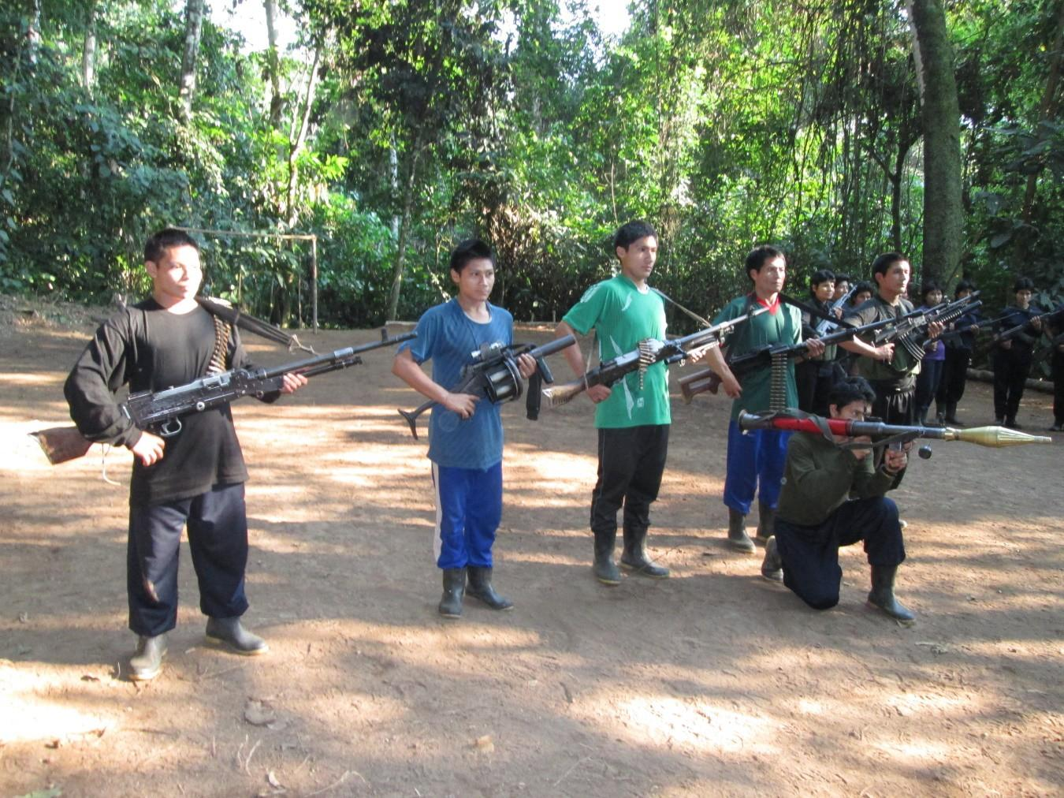
Combatants of the People’s Liberation Army. Marxist-Leninist-Maoist, Gonzalo Thought Communist Party of Peru. Pampa Aurora. North of the Huanta Province, zone of the warrior Vizcatán.

September 2013.
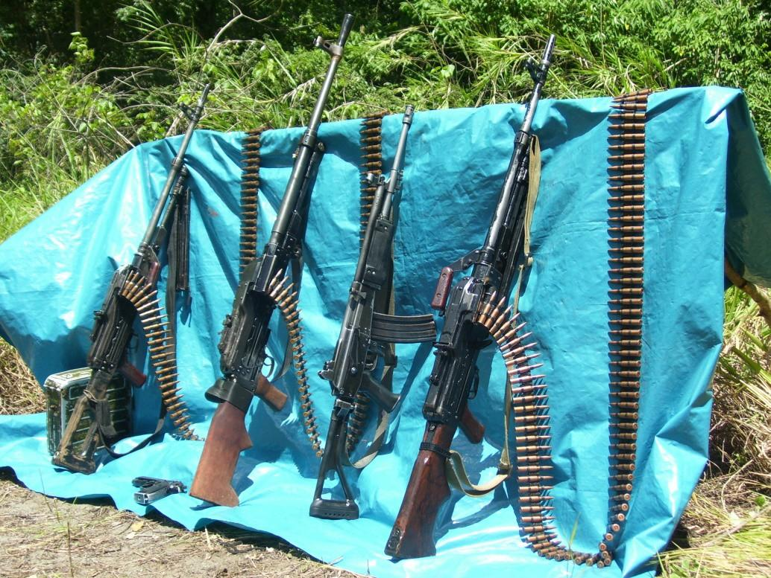

Armaments confiscated on October 2, 1999. Mina Sector. Saniveni River. San Martín de Pangoa. An MI-17 helicopter No. 633 was ambushed.
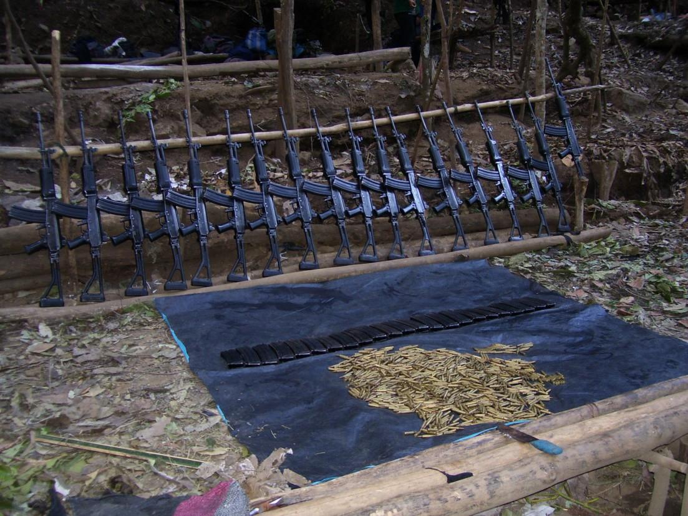
Ambush in Tintay Puncu. Tayacaja. Huancavelica.

October 9, 2008.
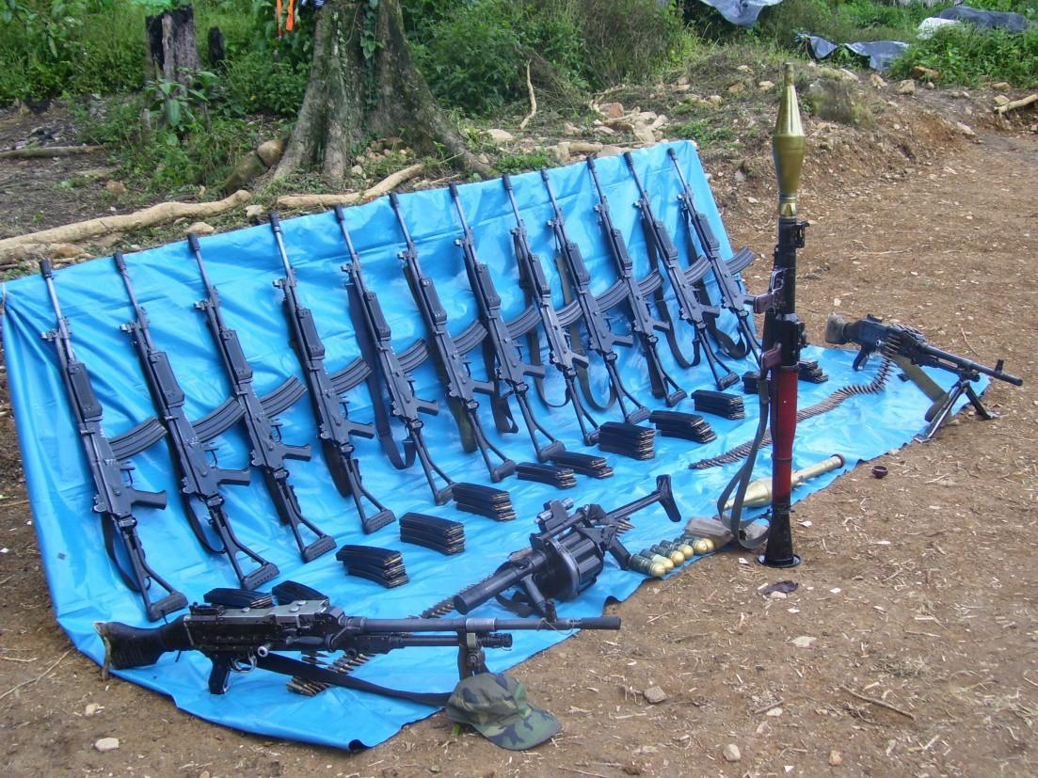

Ambush in Ccompipata. Sanabamba. Huanta. Ayacucho.

April 9, 2009.

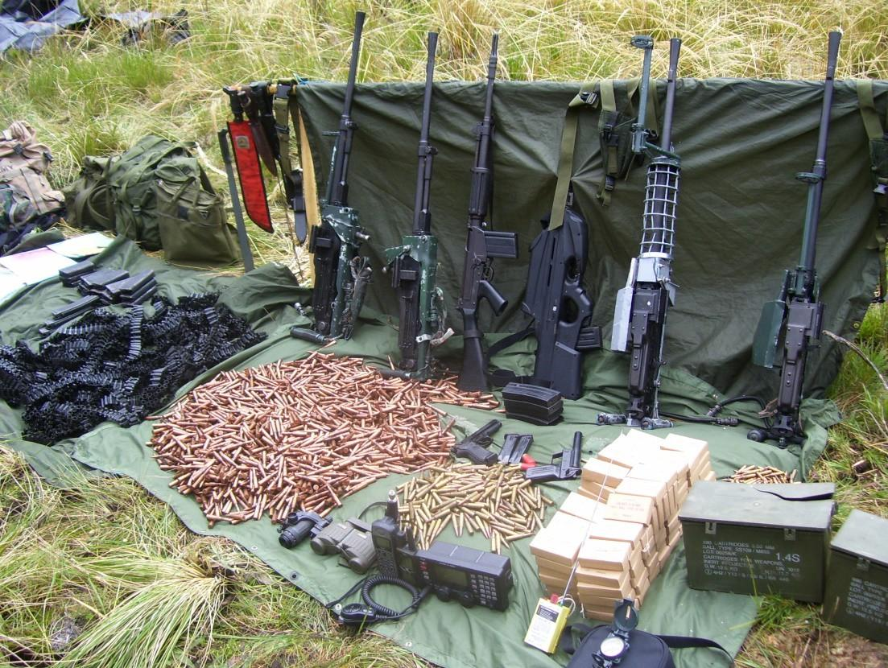

Demolition and ambush in Sinaycocha. Santo Domingo de Acobamba. Junín.
MI-17 Helicopter, Peruvian Air Force No. 640.

September 2, 2009.
Conversations with Comrade Laura...

So, what happened to the so-called “defeat of the Shining Path,” “the defeat of terrorism,” “the peace agreement,” “national pacification,” and so many other tirades? We firmly believe that all this is an infamy against the Party. With revolutionary fervor we unfurl to the wind the red flags of rebellion. Long live the People’s War! It is right to rebel! Storm the heavens! Our invincible weapon: Marxism-Leninism-Maoism, Gonzalo Thought. The reactionaries say: “Surrender your weapons.” We reply: “Come and take them.” Once again we raise to the top the slogan of Chairman Mao: “He who is not afraid of death by a thousand cuts dares to unhorse the emperor.”
Let’s recall some historical facts:
- In the Battle of Thermopylae, King Leonidas of Sparta, in the so-called medical wars between the Greeks and Persians, together with his 1,300 troops, fought bravely in defense of Greece; they did not care about the numerical superiority of the enemy invader, something more than 20,000 troops. History records the monument to these heroes, proclaiming: “Stranger, tell Spartans that we lay here, staying faithful to Sparta’s laws.” Lesson for us: Defend the Party and the Revolution with sacred hands, with our blood, with our lives.
- During the civil war between the Spaniards, the Battle of Jaquijahuana took place between the forces of the Peacemaker la Gasca and Gonzalo Pizarro. Some captains of Gonzalo Pizarro’s side, seeing themselves in unequal conditions, were in favor of capitulation, that is to say, surrendering; one of the warriors said that in his opinion it was shameful for a Castilian to surrender his weapons and, in contrast, he harangued his hosts: “Attack the enemy and die like Romans.” He kept his promise.
- In the Battle of Arica, a week before the arrival of the Chilean parliamentarian, it had already been agreed not to
Vizcatán: The Difficult but Glorious Road of the Revolution

retreat and to instead resist at the cost of their own lives. Reinforcements did not arrive. When the time of the battle came, they immolated themselves and fulfilled their promise: to fight until the last cartridge has been fired. This testimony is found in the Memoirs of Colonel Roque Sáez Peña and the Chilean historian Benjamín Vicuña Mackenna.
What would the opportunists have done? Put their feet up and scurry away like the rats they are.
Remember, us communists are made of special wood, we know what we have to face, we have already faced it. Armed with our undefeated ideology: Marxism-Leninism-Maoism, Gonzalo Thought, we have the fighting spirit of Chairman Mao and Chairman Gonzalo: “He who is not afraid of death by a thousand cuts dares to unhorse the emperor.” “Under the leadership of the Communist Party, as long as people exist, all kinds of miracles can be achieved.”
- January 1836, the black León Escobar, after a violent assault, seized the presidential chair in Lima. Foreign troops had to intervene in this incident. León Escobar was shot after an offer of dialogue by General Francisco Vidal, his corpse was exhibited for three days in front of the cathedral to set an example. Here is Don Carlos Cueto Fernandini, Minister of Education’s phrase during the first government of Fernando Belaúnde Terry:

There are in this small world representatives of almost everything that our country is: APRAists, communists, thieves, murderers, the sexually depraved, crazies, idiots, and people driven by the most extreme hatred and love (…)
Conversations with Comrade Laura...

There is room for everyone in this established order, but the crime considered the most heinous and deserving of the most shocking human and heavenly punishment is to have risen up with rifles to build a new order. In the gloomy dungeons of Peru, the children of the people and the class have launched their resounding war cry that summons the breath of their fellow men. This war cry has become the death sentence of the current system of exploitation and oppression.
As the poet Pablo Neruda said, there are disguises for all tastes, there is room for everyone, but, beware, do not let the communists pass. Peru is, and should be, under the representation of those who were: presidents (constitutional or de facto), Velasco, Morales Bermudez, Belaúnde, Alan García, Fujimori, Toledo, Ollanta; accompanied by: Esparza Zañartu, Mantilla, Chinguel, Montesinos, Martin Belaúnde, the SEPA, el Fronton, the Castro Castro communes, Ancón, and others. All of them have the right to enjoy this carnival that is the oppressive politics of Peru. You shall know it by its deeds.
The Legislative Power of Peru has an extensive record: Julio César Arana, at some time, deputy for Loreto, murderer of natives in the Peruvian jungle in the exploitation of rubber, see Broad and Alien is the World and The Dream of the Celt. Colonel Agustín Belaúnde, deserter of the Battle of Arica, who with the greatest audacity and without the slightest embarrassment, some time later, was deputy for the province of Tayacaja, Huancavelica. In addition to the congressmen: he eats chicken, steals wiring, pimps, kills dogs, and a group of scoundrels who drink the blood and sweat of the Peruvian people between their two cheeks.
- Andahuaylas. After an offer of dialogue and supposed peace, the authors of this uprising were imprisoned and today they pay the price for their audacity in Piedras Gordas.
Vizcatán: The Difficult but Glorious Road of the Revolution

War is not a game. The sacrifice of conscious combatants cannot be used for the shameful act of handing over rifles, like firewood, in piles and in the middle of the street to be condemned to the black dungeons of the reactionary state of Peru. After the events of Andahuaylas, why did the retreat not begin with a plan for new battles? Just by going in the direction of Ocobamba and Ongoy, or failing towards Pacucha, Huancarama, and the Cocas valley, surely the peasant masses would have acclaimed them.
- The events of Bagua. Known by the news media as the Baguazo. The people of Bagua, the Awajun, and Wampis, have rightly claimed extremely rational points in defense of their environment and lands. But the interests of the big bourgeoisie are more important. The citizens of Bagua were considered second class, particularly by Garcia Perez, a well- known conjurer. Things became more and more violent due to the police forces’ participation. Opportunists, gentlemen! If you have an ounce of revolutionary morality left, please learn a lesson. The government and the representatives of the Bagua communities, at the negotiating table, had been in dialogue for 55 days. What was the point of this dialogue? To gain time and prepare the massacre of the peasants, without caring about their own police with 23 of whom dying according to the news. Peace and dialogue, in the present stage, are a means of annihilating the struggles of the people.

The reactionaries are shouting at the top of their lungs: “peace, dialogue!” while their two treacherous hands are wielding the murderous dagger. The reactionary forces, armed with helicopters, tear gas bombs, and AKM rifles attacked the demonstrators in the so-called Devil’s Curve. The Awajun and Wampis defended themselves with sticks, spears, and stones. All of this, trampling, with all the nerve
Conversations with Comrade Laura...

in the world, their charade called a “dialogue table.” We imagine that the government agents would be hypocritically dialoguing to conceal their hyena bloodlust, wanting to annihilate the peasants of Bagua. Well, when the dialogue table was set up, they unleashed the bloody repression. Gentlemen of the government!

Every statesman knows that in an action like Bagua, in a violent conflict like Bagua, one must preserve one’s own forces and annihilate those of the enemy. To annihilate the enemy’s forces does not necessarily mean to kill, but to deprive them of their capacity to resist. And none of this was done by the government of the day and its cabinet. They did not care at all about the lives of the police personnel who were surrounded by fighting and enraged villagers. The result: the disappearance of police personnel.

In order to quench their personal or group thirsts, they are not at all interested in the lives of their own personnel. It has always been like this. We ask ourselves: Why didn’t they evacuate the surrounded police personnel before unleashing the massacre of the Devil’s Curve? The real murderers of the 23 policemen in Bagua were those who led the reactionary state of Peru at that time. Can these reactionary commanders dare to defeat the People’s War? Only in their dreams and delusions. It costs nothing to dream. Keep dreaming. The exploiters always hide behind soldiers from the people, using them as cannon fodder.
- The so-called Shout of Montán [Grito de Montán] on August 31st, 1883. Iglesias, whom I consider to be a traitor, capitulated to Chile, stammering that it was necessary to “end the damage and humiliation of the enemy occupation
Vizcatán: The Difficult but Glorious Road of the Revolution

by practical means (…) Courageous recognition of the defeat (…)” Finally he signed the humiliating peace treaty for Peru.
The courageous thing would have been to defend our territory. What were the practical means to put an end to the enemy invasion? On October 20th, 1883, the Treaty of Ancón was signed, which resulted in the loss of our territory: Tarapacá, Arica, and Tacna. A very high war indemnity: ten million pesos. Moreover, with a complementary treaty, Peru gave Chile 300,000 pesos per month for the maintenance of the Chilean troops that occupied our territory. This peace agreement was humiliating for the defeated and Chile not only knocked down Peru, but also put its foot on it. Let us remember, the rope breaks at the weakest point. The Chilean government recognized as representative of Peru, precisely this traitor Iglesias and only with him did it sign the Treaty of Ancón. The traitors, the faint-hearted, the workers’ sellouts, pardon me, the sellouts, are always praised and commended by the invaders, the reactionaries, and the imperialists.
In war, the side who asks for dialogue is the defeated side. This defeated side has a double intention: to regain strength by means of truce, take a breather, and then launch a furious counter-attack; the other feels lost and wants to preserve part of his interests at the negotiating table to conserve part of his strength and attack again at a later date. This is also the way restorations take place.

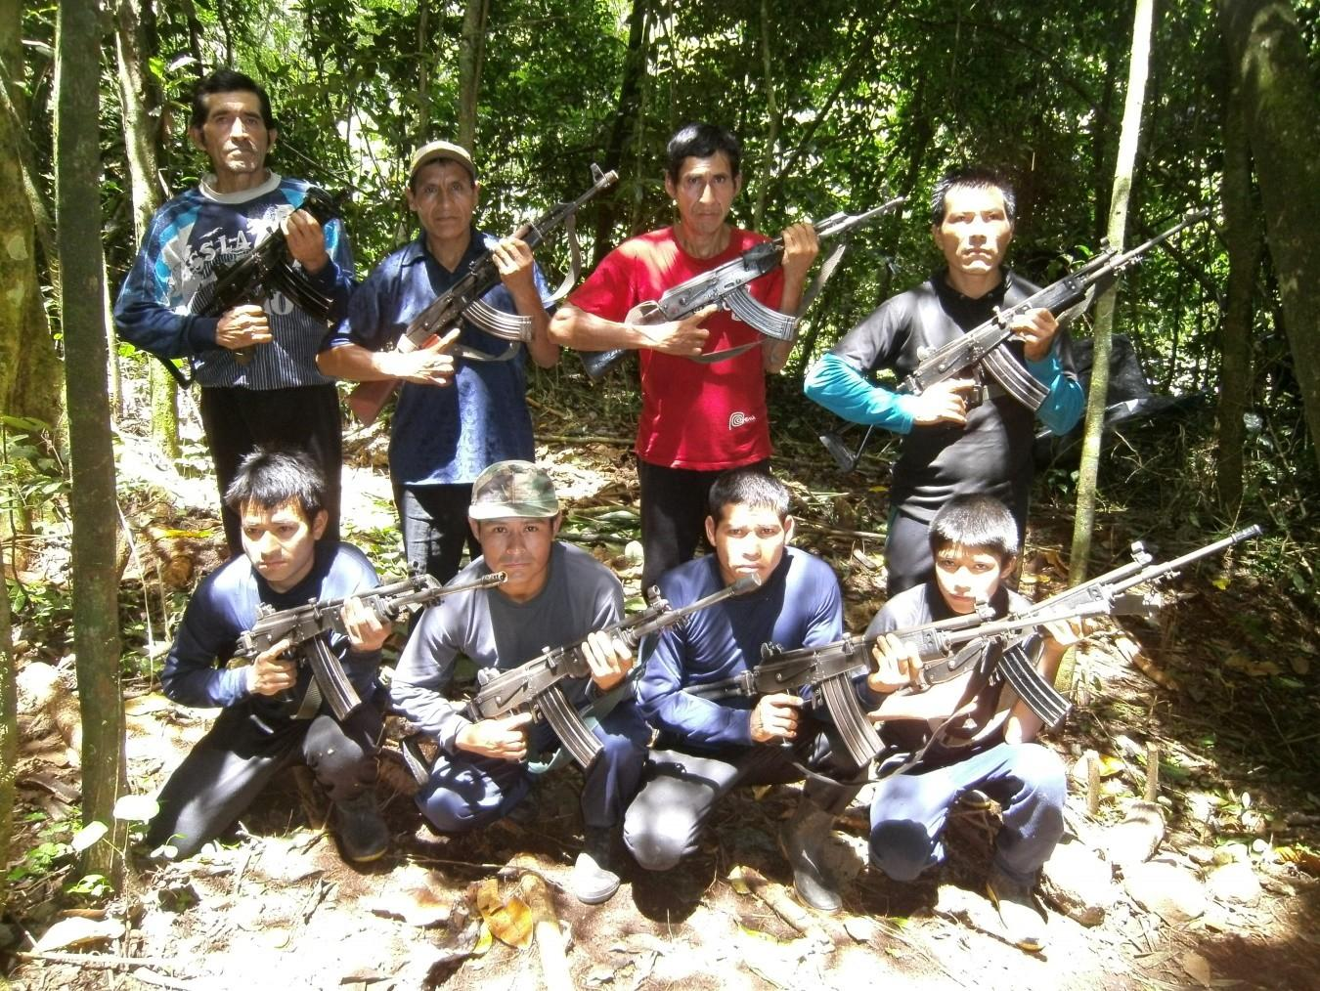
Combatants of the People’s Liberation Army in the sector called Churrubamba, Huanta Province — Ayacucho.

February 2012.
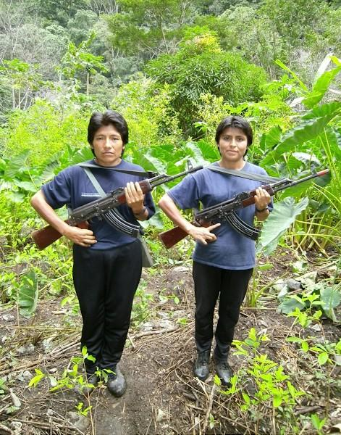
Comrades Laura and Mariela. Roblepampa. Tayacaja Province. Huancavelica.

August 2012.

Photo not included
The half that hold up the sky. People’s Liberation Army combatants. Pampa Aurora. Huanta Province — Ayacucho.

September 2013.
Conversations with Comrade Laura...

What is the “Political Solution to the Problems derived from the War,” for which the opportunists of MOVADEF are clamoring so much about? There are two conceptions in the world, two ways of looking at political problems, two parties in conflict.
The reactionary government of Peru, which represents the big bankers, the big landlords, and the big bourgeoisie in its two factions, comprador and bureaucrat, hold power and is the oppressor class; this on the one hand. And, on the other hand, the Peruvian people: workers, peasants, petty-bourgeoisie and even the national bourgeoisie; they are the oppressed class. The oppressors are supported by a powerful army, the backbone of this state. In order to stay in power, every certain period they have generated the so-called general elections for a change of authorities to continue oppressing the people.
What do the opportunists of MOVADEF pretend, then? To register as a front, a political party, that fulfills the requirements imposed by this reactionary state and thus fulfill their dreams of becoming mayors, regional governors, congressmen, and even presidents of the republic. That is to say, the black road of electoralism, a disease discarded for a long period of Party reconstitution. This shameful stage of parliamentary cretinism took place from the 1930s onwards, with the abandonment of the Marxist-Leninist theses of Mariátegui and the usurpation of the leadership of the Party by the opportunists headed by the subject Ravines. The period of Reconstitution led us to build the heroic combatant, the Party, to initiate the armed struggle, allowed us to travel the difficult but glorious road of encircling the cities from the countryside, the road of People’s War to establish, in the not too distant future, the People’s Republic of Peru, Socialism, and finally Communism.
Vizcatán: The Difficult but Glorious Road of the Revolution

“Comrade Laura, What Is Your Opinion on the Truth Commission?”

First off, it would be necessary to judge what class standpoint those who make up this so-called “Commission” have. Who has constituted this organization? The reactionary government of Peru, the Peruvian state at the service of mainly U.S. imperialism. Let us look at its members. Has Mr. Salomón Lerner ever raised a single finger, even for a day, at least for a minute, against the oppression and misery of the people? No. What can we expect from this gentleman? Nothing. That so- called commissioner, Carlos Iván Degregori, has only compiled some isolated facts on the struggles of the people of Ayacucho, being not even a spectator, but, widely related, part of the time of Velasco Alvarado, whom he called a “reformist.” Does he have any commitment or affinity with the people? No. Mr. Alberto Morote Sanchez, reactionary and retrograde when he taught at the National University of San Cristóbal de Huamanga, has never even said the word “people,” for him there is no people. This figure named Tapia, who once proclaimed himself to be an admirer of the Revolutionary Left Movement, what is his way of thinking? This gentleman applies the policy of the jackal in front of the lion; shoeshine boy, unconditional and faithful servant of the reactionary governments of the day and of U.S. imperialism, who, in order to ensure his daily bread and butter, goes along with his masters, he takes pleasure in receiving crumbs; this creeping and careerist personage has become a knife to the Peruvian people. What can we expect from this parasite? Is this rascal just stupid or is he our enemy? He is not stupid, he has demonstrated his servile capacity next to and as a trivial monkey of the old Peruvian state. He has opened his black jaws against Chairman Gonzalo, therefore, he is our enemy.
Conversations with Comrade Laura...

It is worth commenting on . . . this Commission was subordinated to the reactionary state of Peru and Yankee imperialism, as such, it had no independence and its conclusions had to be governed by the interests of the Peruvian state and Yankee imperialism; we make this statement because of the way of thinking and class position that they defend and will continue to defend. Furthermore, because of the incident that occurred at the moment of publication of the conclusions reached by the Commission; the congressmen, ministers, the most obscure characters and known enemies of the people, the armed forces and the police, did not agree with the publication of these “conclusions.”
The pretext, “these conclusions threaten the democratic institutions of the nation,” what was the response of the Commission? That they would publish it abroad. In this tug of war, they decided to publish it, choosing to blame the Party for the deaths and exonerating the armed and police forces of the genocide against the Peruvian people. Subsequently, this same Commission throws to the wind the tale of national reconciliation to which the opportunists and rotten revisionists of MOVADEF join in. Thus, this so-called “Truth” Commission smacks of the reactionary state of Peru and Yankee imperialism. This bastard organization, an instrument of U.S. imperialism and the reactionary government of Peru, claimed to be an organization that preaches the truth, with the greatest cynicism and impudence, has worked for the reactionary government of Peru to safeguard the interests of the exploiters to the detriment of the Peruvian people.

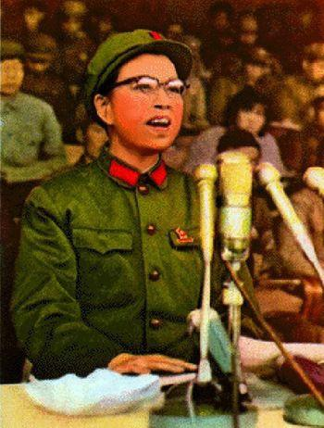
Comrade Jiang Qing, flag-bearer of the Great Proletarian Cultural Revolution, companion, comrade, and loyal disciple of Chairman Mao Zedong.

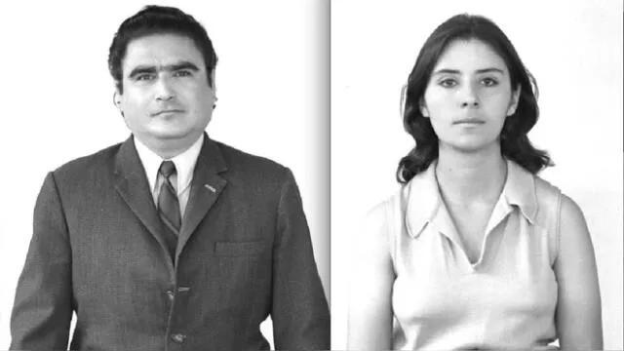

Dr. Abimael Guzmán Reinoso, Chairman Gonzalo, Chairman of the Communist Party of Peru, and Augusta La Torre Carrasco, Comrade Norah. Teacher of Communists, the eagle of the Party. A life totally and completely dedicated to the Party and the Revolution.
Vizcatán: The Difficult but Glorious Road of the Revolution

“Comrade Laura, We Want Your Final Words on This Occasion.”

We proclaim from here the future birth of the People’s Republic of Peru, Republic of Workers and Peasants; for this we rely on the Communist Party of Peru, with a just and correct ideological and political line, Marxism-Leninism- Maoism, Gonzalo Thought, and a People’s Liberation Army led by such a Party, which are a guarantee of triumph . . . We raise to the top our resounding war cry, against the hurricane of propaganda against the Party and the Revolution. “The bird sings in search of the echo of its peers.” Our actions and experiences will move and summon the hearts eager for justice. The sun already shines in our pupils and stirs uncontainable in our hearts. This is also our firm commitment . . . To fight.
A separate point . . . I feel immense affection for my father, my mother, my brothers, and especially for my daughter. Special circumstances mean that we are not together. And it is worth it! . . . it is the Revolution . . . it is the Party . . . it is Marxism-Leninism-Maoism, Gonzalo Thought . . . I want them to remember me with joy and for my life to be a mark of pride for them. I know that tears flow from their eyes . . . but may those tears not be tears of grief, but rather the profound expression of a class sentiment. And as other combatants have already said: “I have lived for joy, for joy I go to combat, and for joy I die, and it would be a disservice to place the angel of sadness on my grave.” My flag is red and my badge is the hammer and sickle. We consider ourselves children of the Party, of the Revolution, and of Chairman Gonzalo, and for them I give my life . . . this is my decision. Thank you . . .

103

Manifesto of the Prisoners of War of the Shining Trenches of Combat
November 2017
We, the Political Prisoners and Prisoners of War of the Communist Party of Peru, express our greetings and conscious and voluntary subjection to our beloved and respected Chairman Gonzalo, our Leadership, Leader of the Party and the Revolution, the greatest living Marxist-Leninist-Maoist on the face of the Earth, who has become the world’s top prisoner of war, a great philosopher, continuator of Marx, Lenin, and Chairman Mao.
From this trench of combat, we join the campaign for the defense of Chairman Gonzalo, the immediate task of defending his health and life in the face of the rigors of prison imposed by the CIA-SIN22 in the fascist concentration camp of the Callao Naval Base through its navy henchmen; simultaneously, the struggle for the defense of the Great Leadership and its all- powerful thought, demarcation, rejection, and repudiation in the face of the sinister attacks, infamies, and other lies mounted by imperialism, mainly Yankee imperialism, in collusion and struggle with reactionaries and revisionists of all stripes and types who seek to discredit him, isolate him, and continue in their dark dream of assassinating him, a monstrous plan that has been failing for more than 25 years, since the left took up the campaign in 1992: “In defense of the Great Leadership, Against the Genocidal Dictatorship!”
To this day, they show us that defending the Great Leadership is a key and decisive issue, and that its all-powerful ideology, Marxism-Leninism-Maoism, Gonzalo Thought, is the Party’s red line that guarantees its course and road. It is vital for the strengthening and structuring of the left.
Likewise, we express our greetings and full and unconditional support for our proletarian ideology of Marxism-Leninism-Maoism, principally Maoism, for the World

22Central Intelligence Agency–National Intelligence Service. — PFP
Vizcatán: The Difficult but Glorious Road of the Revolution

Proletarian Revolution and its concrete and creative application, the all-powerful Gonzalo Thought, which is of vital importance for the Peruvian Revolution.
Likewise, we express our greetings and full, voluntary, and unconditional subjection to our heroic fighter, the Communist Party of Peru, a war machine, to its Party leadership system, which, in the midst of complex and difficult circumstances, has been leading the People’s War for more than 37 years, persisting in the midst of the storm, overcoming difficulties, overcoming mistakes and limitations, fulfilling the pending task: the General Reorganization of the Party. Its realization will be an important milestone in the history of the Party, an example of struggle and persistence for the World Proletarian Revolution and of the validity of Maoism: everything grows out of the barrel of a gun.
We also express our greetings and our full, conscious, and voluntary subjection to all Party events, to the Marxist First Congress, the Marxist-Leninist-Maoist, Gonzalo Thought Congress, an enduring milestone of victory. Child of the Party and the People’s War, sanctioned at the highest level our Basis of Party Unity, the foundation that guides all our actions, with its threefold content: 1) Ideology: Marxism-Leninism- Maoism, Gonzalo Thought, principally Gonzalo Thought; 2) The Communist Program; and 3) The General Political Line with its center, the Military Line; to the First, Second, and Glorious Third Plenum, historic and transcendental, the second milestone in the history of the Party, its masterful synthesis, the belligerent and resplendent speech of September 24th, 1992, of Chairman Gonzalo, our agreement to the working sessions and subsequent agreements that emerged.
We also express our greetings and conscious and voluntary subjection to the invincible People’s War, a grandiose epic that for more than 37 years has continued, persisted, and combated
Manifesto of the Prisoners of War...

against wind and tide, crushing the sinister counter-subversive war that, under the command, leadership, and execution of its Yankee mercenaries, develops its strategy of low-intensity warfare, crushing their genocidal campaigns of encirclement and annihilation by holding high the red flag in the glorious and heroic Vizcatán as the vortex of red power that radiates throughout the Main Regional Committee, the country, and the world, fills us with communist joy and calls us to sweep away our problems and strive to fulfill the Party tasks.
Finally, we extend our greetings to Gonzalo’s iron legions, to the People’s Liberation Army, to the heroic and combative combatants, to the masses organized in the New Power, to the masses who support us, to our sympathizers, and to the heroic Peruvian people who, with their daily fight and struggle, call on us to better fulfill our expedition.
With these introductory remarks reflecting our position on fundamental issues, we would like to point out that we have recently received the document Conversations with Comrade Laura, and have read it very carefully, although we have not yet had time to study it thoroughly among our ranks.
In general terms, the context of fascist concentration camps, which have become human warehouses where overexploitation and overcrowding reign amid collusion with the taytas,23 who operate under corruption, imposing reactionary-feudal discipline to live off the backs of prisoners and their families, imposing their networks of informants, codes, and repentants, where any complaint is considered dangerous to the status quo and is considered a troublemaker, that is, to remove the taytas in order to impose themselves. That is why political activity is allowed for those in the MOVADEF “because they are for dialogue” or those in the Quispe clan “because they are armed.”

23“Thugs.” — PFP
Vizcatán: The Difficult but Glorious Road of the Revolution

We do not exist, and if anyone speaks out, they are quickly identified to the reaction.
In the midst of our work, we reiterate that we have read the document with great attention and a deep sense of class sentiment, and it fills us with great communist joy, and even more so with a great sense of responsibility in the fight.
Firstly: “The bird sings seeking the echo of its fellow birds.” The conversations document is fundamentally Gonzalo Thought, and Comrade Laura, forged and shaped by Chairman Gonzalo, clearly and precisely grounds us in the process, the current situation of the Party, the People’s War and its perspective, filling us with optimism and strengthening our souls.
The revisionist and capitulationist right-opportunist line led to the surrender of the Great Leadership in collusion with the CIA-GEIN,24 they staged the sinister counter-revolutionary hoax of the CIA-SIN “peace letters,” dismantled Party apparatuses, surrendered and assassinated comrades of the left, handed over weapons and placed the New Power at the mercy of the genocidal enemy for its vicious bombings, encouraged repentance and renunciation, usurped various committees to abandon the road of Marxist-Leninist-Maoist, Gonzalo Thought People’s War, and became mercenaries in the service of the highest bidder.
But just as after Mariátegui’s death, with the arrest of the leadership, they unleashed and continue to unleash a counter-revolutionary campaign to abandon Gonzalo Thought. Chairman Gonzalo teaches us: “The essence and substance of Gonzalo Thought is encountered in the General Political Line,” and if they “attack the line, they attack the Congress, they are

24Central Intelligence Agency–Special Intelligence Group. — PFP
Manifesto of the Prisoners of War...

finished.” He further emphasizes that at this moment in time, “we are between the Congress and the Conquest of Power in the Entire Country (CPTP).”
The difficult and complex turn of events led to the dispersion of the left. Various committees and bases battled to hold on, repair, and fight to reorganize in midst of the People’s War, sometimes in isolation, sometimes in convergence with other comrades, sometimes setting up work so that unresolved errors would not send us back to the beginning, combating sinister capitulationism, pessimism, and the repercussions of the enemy’s ideological dynamic that “the Party is destroyed and the People’s War defeated.” We combated this on a daily basis, but with confidence and revolutionary faith, knowing that comrades with varying degrees of development were following a similar road, and that if, in the end, we were few, the struggle would require greater effort and time. Hence the transcendental importance of “the bird sings,” the eagle being present and calling us to fight to fulfill our journey, to carry out our Party tasks.
Comrade Laura, the solidity with which you ground Gonzalo Thought, even taking data from the reaction itself and resorting to history, brings us closer in the forge of Gonzalo Thought, empowering the red in our souls. It is fitting that the left should be structured and united around the fraction that is rising up in the Main Regional Committee, in the face of the rat José’s usurpation.
Chairman Gonzalo taught us: Just as we had to crush and sweep away a right-opportunist line for ILA-80 — there was a need for a red fraction — so too for the Conquest of Power in the Entire Country there will be a need for a red fraction, that is a law. Currently, all comrades, combatants, and masses are firmly closing ranks around Comrade Laura and other comrades,
Vizcatán: The Difficult but Glorious Road of the Revolution

combatants, and masses who, in an arduous, hard, and tenacious two-line struggle, firmly wielding Gonzalo Thought and with guns in hand, are fighting the revisionist usurpation of the Main Regional Committee and the current leadership.
Lenin already taught us when the Mensheviks usurped power: “What, where is the Party? The Party is on the left, among those who maintain the principles, the line.” Where is the Party? In the forging of Chairman Gonzalo, in his making, in those who, steeled with Gonzalo Thought, show their mettle in words and deeds, and this is embodied in its highest expression by Comrade Laura and the contingent that is fighting in this tenacious, historic, and momentous two-line struggle of importance for the Peruvian Revolution and the World Proletarian Revolution.
In the second place: A few months ago, we received a report with which we expressed our agreement: “Under the guidance of the Congress, General Reorganization of the Party in midst of the People’s War!” We consider it correct and fair, because, as it also points out, only by holding fast to the Leadership and Gonzalo Thought, developing a firm and astute two-line struggle to keep the Party red, can we advance in the People’s War and firmly maintain its course.
The new revisionism of all stripes, whether it be the right- opportunist line — headed by the rat Miriam — or what we consider to be the left-opportunist line headed by the mercenary rat José, aim to deny the First Congress, the former calling for their “Second Congress” that they will never concretize or carry out, and the latter denying it with a stroke of the pen. The essence of the First Congress: the Basis of Party Unity and, as the Party rightly and correctly pointed out, the Basis of Party Unity is the foundation that guides all our actions and, obviously, how Chairman Gonzalo carried out the
Manifesto of the Prisoners of War...

reorganization of various committees with the Congress and made a leap forward in the development of the Party work and the People’s War. We also close ranks around this, we unite, we solidarize with the fight being carried out by Comrade Laura and the entire left with People’s War, wielding the Basis of Party Unity, Gonzalo Thought, which in essence is: People’s War until Communism, which they are imposing in the Party’s Main Regional Committee as part of the General Reorganization of the Party. Step by step, solid foundations are being laid, preparing for a leap forward in Party work and the development of the People’s War.
Already, the masses who visit us from the area point to the new winds with hope and optimism. In a context of crisis and collapse of imperialism, mainly Yankee imperialism, within the third moment of Contemporary Peruvian Society of general crisis and destruction of bureaucrat-capitalism, and as Chairman Gonzalo and the Communist Party of Peru stated, the crisis of bureaucrat-capitalism intensifies in the second half of each decade, and it is at this juncture that the fascist, genocidal, and traitorous regime currently headed by the Yankee Kuczynski is sinking and will sink amid its strong contradictions and the conflict between factions of the big bourgeoisie and groups that swarm within it. The people’s movement and its growing rejection of the prevailing system seek to tie it to the electoral road of the upcoming regional and municipal elections, precisely for October 7th, the anniversary of the Communist Party of Peru.
The combat is agreed upon: they with their bureaucratic road of oppression and exploitation, and us with our democratic road as a popular road of liberation, a road of emancipation, of sweeping away the three mountains that we are now concretizing, wielding our Basis of Party Unity as the foundation that guides our action, promoting the General Reorganization
Vizcatán: The Difficult but Glorious Road of the Revolution

of the Party, with the work of the left in the Main Regional Committee as our priority. Thus, we close ranks firmly around Comrade Laura and the contingent that fights alongside her, because the two-line struggle’s development there is of vital importance and historical significance for the Peruvian Revolution and the World Proletarian Revolution, all in the midst of the People’s War. The victory that will necessarily be achieved will be a resounding call for the development of the People’s War and will drive forward the development of the new great revolutionary wave led by Maoism, inextricably and inseparably linked to the Campaign for the Defense of our beloved and respected Chairman Gonzalo, our Great Leadership, Leader of the Party and the Revolution, giving our own lives.

Warm regards, communist greetings.
November 2017.
Titles from Prairie Fire Publishing

What Is to Be Done?
by V. I. Lenin
Classics • 978-1-257-98209-7 • $17 USD

Foundations of Leninism
by J. V. Stalin
Classics • 978-1-300-11927-2 • $17 USD

The Pragmatist Philosophy of the Modern Bourgeoisie
by Chen Yuan-hui
Other Works • 978-1-300-12712-3 • $14 USD

Selected Works of Kaypakkaya
by İbrahim Kaypakkaya
Classics • 978-1-300-00229-1 • $32 USD

Notes on the History of the Communist Party of Turkey/Marxist-
Leninist
by Periódico Mural
Other Works • 978-1-300-18338-9 • $8 USD

General Political Line
by Chairman Gonzalo
Classics • 978-1-300-39308-5 • $15.00

Ludwig Feuerbach and the End of Classical German Philosophy
by Friedrich Engels
Classics • 978-1-300-39371-9 • $11.00

Seven Interpretive Essays on Peruvian Reality
by José Carlos Mariátegui
On the Bourgeois-Democratic State
by Chairman Gonzalo
Classics • 978-1-300-41288-5 • $13.00

In Defense of Marxism
by José Carlos Mariátegui
Classics • 978-1-300-41284-7 • $17.00

The New Democratic Revolution is the Main Force of the World Proletarian Revolution
by Communist Party of Brazil
Classics • 978-1-300-41424-7 • $35.00

Wage-Labor and Capital & Value, Price, and Profit
by Karl Marx
Classics • 978-1-300-41444-5 • $13.00

On Practice & On Contradiction
by Mao Zedong
Classics • 978-1-300-41438-4 • $11.00

Marxism, Mariátegui, and the Women's Movement
by People's Women's Movement
Other Works • 978-1-300-25024-1 • $11.00

Lenin and the Militarized Communist Party
by Communist Party of Brazil (Red Fraction)
Other Works • 978-1-300-13391-9 • $10.00

Maoism — What It Is and What It Is Not
by Klassenstandpunkt
Other Works • 978-1-300-25763-9 • $12.00

The Supreme Court: Citadel of Slavery
by Elizabeth Lawson
The Thorn and the Carnation
by Yahya Sinwar
Other Works • 978-1-300-32826-1 • $30.00

Post-Modernism Today
by Siraj
Other Works • 978-1-300-32808-7 • $15.00

On the Road to Bolshevization
by Communist Party USA
Other Works • 978-1-300-33576-4 • $10.00

The History of May Day
by Alexander Trachtenberg
Other Works • 978-1-300-39324-5 • $10.00

Communism, the Women's Liberation Struggle, and a Critique of Bourgeois Feminism
by Nuova Egemonia
Other Works • 978-1-300-45926-2 • $20.00

Twenty Years in Underground Russia
by Cecilia Bobrovskaya
Other Works • 978-1-300-40943-4 • $16.00

The Great San Francisco General Strike
by William F. Dunne
Other Works • 978-1-300-46782-3 • $14.00

The Role of the Zionist Terror in the Creation of Israel
by Bassam Bishuti
Other Works • 978-1-300-44167-0 • $16.00

Economic Doctrines of the Capitalist Epoch
by Economics Institute of the Academy of Sciences of the USSR
Three Major Struggles on China's Philosophical Front
by Revolutionary Mass Criticism Writing Group
Other Works • 978-1-300-42351-5 • $11.00

Our Road
by League of Poor Peasants
Other Works • 978-1-300-47076-2 • $11.00

